Model calibration

Composite Bi-Phase models 30 and 131 for elastic, damage and failure

- PAM-CRASH material model 30 is for solid and 131 for multi-layered shell elements.
- Within these models different ply types can be used for different fibre reinforcements and damage laws. This document covers the ESI composite Bi-Phase damage law for:
- Ply type 0 for uni-directional composites (solid and shell elements).
- Ply type 8 for woven type composites (shell elements only).

Problem description
Outline | Application of the Bi-Phase composite damage model to a single element under various loadings
Analysis type(s): | Explicit
Element type(s): | Applicable to shell (model 131) and solid elements (model 30)
Materials law(s): | PAM-CRASH material models 30 and 131 (ply types 0 and 8). Fibre and matrix are calibrated for:  - Orthotropic elasticity  - Orthotropic fibre and matrix damage with failure
Model options: | Boundary conditions, Imposed velocity loads, Composite materials
Key results: | Outputs for composites (fibre stresses and strains, matrix damage, fibre orientations… )
Prepared by: Date: | Anthony Pickett, ESI GmbH/Institute for Aircraft Design, Stuttgart September 2012

Background information

Pre-processor, Solver and Post-processor used:
- Visual-Crash PAM: To assign control, material, loading, constraint and control data.
- Analysis (PAM-CRASH Explicit): To perform the explicit Finite Element analysis.
- Visual-Viewer: To evaluate results for time history plots, stresses and strains, etc.

Prior knowledge for the exercise
It is assumed the user has a working knowledge of Visual and PAM-CRASH.
Problem data and description
Units: kN, mm, kg, ms
Description: Single shell element 10mm * 10mm and 1mm thick
Loading: Imposed constant velocity at 1mm/msec (duration of study 1msec) ⇨ total displacement 1mm giving an engineering strain 0.1 (= 10%)

Loading cases:
1
2
3
4
1
x
y
Case 1: Axial fibre loading Case 2: Transverse loading Case 3: Shear loading

Material: The composite analysed is a UD ply (E_{fibres} = 230 GPa, E_{matrix}= 5 GPa ) with an assumed fibre volume ratio (V_{f}) = 0.5 (=50%).
Assume for simplicity the shear modulus (G₁₂=G₂₃=G₁₃) = 7 GPa, and Poisson’s ratios are ν₁₂=v₂₃=v₁₃=0.3. The density is 1.8*10⁻⁶ kg/mm³.
Supplied datasets
All completed datasets are supplied. The main aim is to demonstrate the strategy for model calibration which is done here using the shell element (material model 131, ply type 0).
Calibration for orthotropic elastic properties:
Fibre direction in tension Mat131_TensionX_Elastic.pc
Fibre direction in compression Mat131_CompressionX_Elastic.pc
Transverse direction in tension Mat131_TensionY_Elastic.pc
Shear loading Mat131_ShearXY_Elastic.pc
Calibration for damage and failure:
Fibre direction in tension (tensile fibre failure) Mat131_TensionX_FibreFailure.pc
Shear loading (matrix shear failure only) Mat131_ShearXY_MatrixShearFailure.pc
Fibre dir. tension (tensile fibre and shear failure) Mat131_TensionX_FibreFailure+MatrixShearFailure.pc
Transverse matrix failure in tension Mat131_TensionY_Failure.pc

Part 1: Basic input data

Typical model loadings and supports
(e.g. for dataset Mat131_TensionX_Elastic.pc which is loaded in the positive x-direction)
Open the dataset in Visual-Crash PAM (VCP) and study the supports and the loading:

1. In the Loads > Displacement Boundary Condition definitions you
will find:
- Node 1 is fully constrained.
- Node 2 is fully fixed, except free in the x-direction.
- Node 4 is fully fixed, except free in the y-direction.

2. In the Loads > 3D BC nodes 2 and 3 are loaded at a constant velocity
in the positive x-direction (for tension fibre loading).
1
2
3
4
1
x
y
Remark: This simple setup ensures the element is properly supported and has pure tension/ compression loading in the x-direction with free contraction/expansion in the y-direction.
Ply, Material and Part data cards
Note in the dataset:
- The parts data contain information on geometric data such as the reference fiber orientation. A link to associated material data (variable IMAT) is also made.
- The materials cards (IMAT) contain information on density, the number of plies in the laminate and stacking sequence (for shells only). Within this stacking sequence information on each ply includes the reference ply set (parameter IDPLY), the ply thickness and a fibre orientation angle.
- The ply cards (IDPLY) contain all ply mechanical data for stiffness, damage and failure.

Considering the sequence in which the data refers to each other (1→2→3) it is best to define things in reverse order, i.e. ply data first, then materials and finally parts; all three are needed.

Ply cards (e.g. Ply elastic properties for dataset Mat131_TensionX_Elastic.pc).
In the ply cards you will find mechanical and optional damage/failure data assigned to the matrix and fibres.
- Note that the Bi-Phase model separates fibre direction (dir 11) properties into fibre and matrix mechanical data and combines these with the Law of Mixtures (LOM). But for transverse (dir 22) and shear (dir 23) the modulus represents a homogenised value.
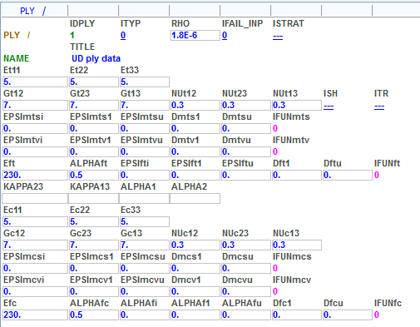
E.G. for fibre tension the LOM gives E_{11t} = E_{ft} * V_{f} + E_{t11} * (1 - V_{f}),
where E_{ft} is fibre modulus (230 GPa), E_{t11} matrix modulus (5 GPa) and V_{f} fibre volume ratio (ALPHAft =0.5)
- The top half of the input contains tension data and the lower half compression data. These two sets may be different and each is used depending on the element state of hydrostatic stress.
Material cards (e.g. Material properties for dataset Mat131_TensionX_Elastic.pc).
- The number of plies in the laminate are defined (in this case NOPER=1) and for each ply an associated ply number (IDPLY), the ply thickness (THKPL) and fibre angle (ANGPL) are specified. Note the fibre angle is with respect to a reference vector defined in the Parts cards (see below).
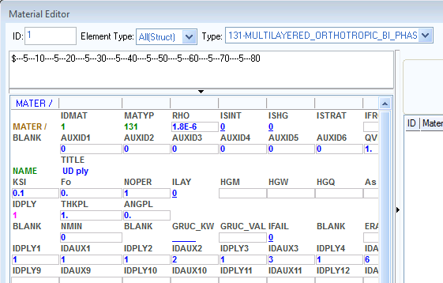
- Special output results to the .THP and .DSY files (or .ENF file if used) are possible such as fiber, transverse and shear stresses/strains. For this the ply number in the laminate lay-up and an auxiliary reference number for the variable to be output are given. Examples of auxiliary reference numbers are Aux’s 1-3 for fibre strain11, strain22 and shear strain12, and Aux’s 6-8 for corresponding fiber stresses. Auxiliary reference numbers are also available for results such as fibre and matrix damage.
131
Part cards (e.g. Part properties for dataset Mat131_TensionX_Elastic.pc).
- A connection to the associated material is made via the IDMAT number (in this case = 1).
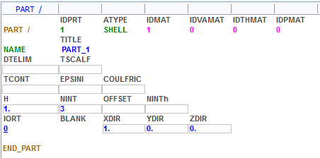
- A vector for the reference fibre direction is defined. Here the global vector option with a reference vector 1,0,0 (i.e. the global x-direction) is used. For shell elements the transverse direction is normal to the fiber direction in the element plane.
- For solid elements two reference vectors are required.

Part 2: Calibration of orthotropic elastic properties

Tension
Using dataset Mat131_TensionX_Elastic.pc and the results files.
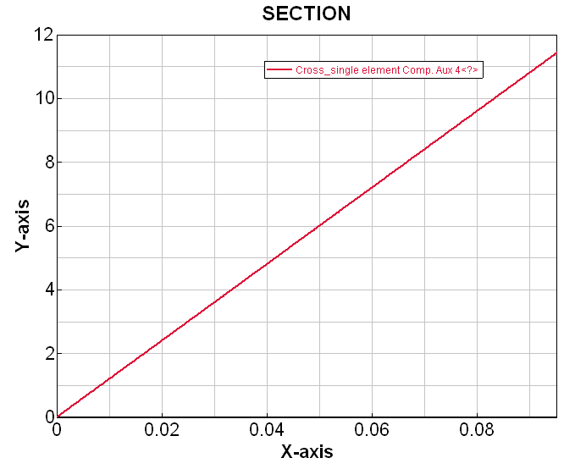
Create a cross plot time history of shell element Aux4 versus Aux1 for element stress11 versus element strain11 in the fibre frame. The slope of this curve is the composite stiffness (=117 GPa) in the fibre direction. This approximately corresponds to the composite stiffness in the fibre direction using the law of mixtures.
Note: The element maximum strain (x-axis) is 0.095 which is the natural logarithmic strain (not conventional engineering strain). All input information and output results use natural logarithmic strains.
Engineering strain: The imposed velocity gives a nodal displacement of 1.0mm. For an initial element length of 10mm the engineering strain is,
ΔL/Lo = 1.0/10.0 = 0.1
Logarithmic strain: Is defined as,
ln(L/Lo) = ln(11.0/10.0) = 0.0953
Compression
Using dataset Mat131_CompressionX_Elastic.pc and the results files.
The dataset is identical to the tension case above, except that compression loading is applied in the fibre direction (imposed using a scale factor of -1 in the appropriate 3D BC cards).
tension
compression
To demonstrate the possibility for different compression stiffness the compression fibre modulus is changed to 180 GPa (tension = 230 GPa); all other mechanical data is unchanged.
The curve shown uses the above tension curve and the Chase Curve(s) option with file Mat131_CompressionX_Elastic.THP to add the new compression curve result.
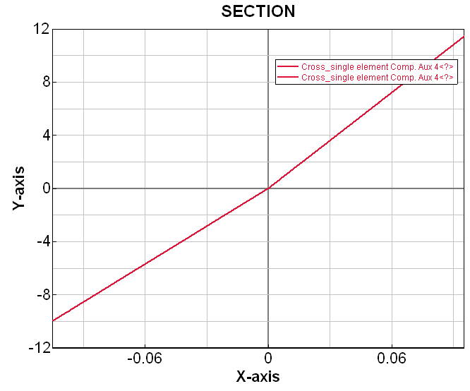
The compression stiffness approximately corresponds to the value computed from the compression law of mixtures.

Transverse tension
Using dataset Mat131_TensionY_Elastic.pc and the results files.
In this dataset velocities are applied to nodes 3 and 4 in the positive y-directions giving an engineering strain of 0.1 (=0.095 logarithmic). The nodal boundary conditions are unchanged.
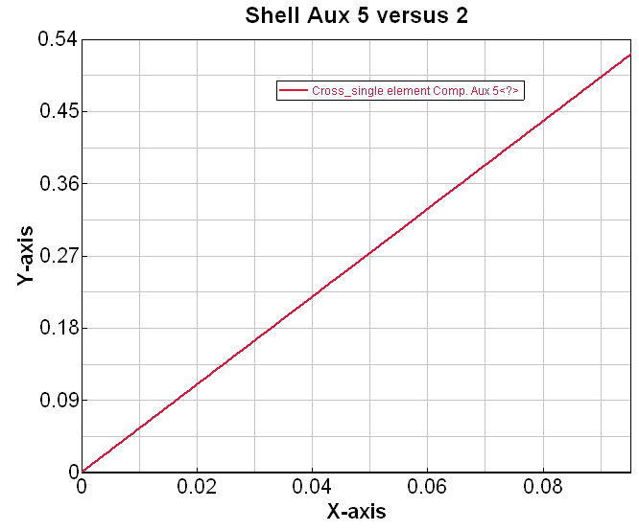
Create a cross plot time history of shell element Aux5 versus Aux2 for element stress22 versus element strain22 in the fibre frame. The transverse stiffness is the slope of this curve.
Note: The law of mixtures does not apply as a homogenised modulus is used for transverse (E=5 GPa) and shear. Also, the slope is not quite equal to this input modulus due to interaction of stress11 and stress22 via Poisson’s effect.

Shear
Using dataset Mat131_ShearXY_Elastic.pc and the results files.
For pure shear loading velocities are now applied to nodes 3 and 4 in the negative y-direction and to nodes 2 and 3 in the positive x-direction using the same function curve, also the fibre directions are rotated 45°. All other boundary conditions are unchanged.
Create a cross plot time history of shell element Aux6 versus Aux3 for element shear stress12 versus element tensor shear strain12 in the fibre frame.
Note: PAM-CRASH input and output use ‘tensor’ shear strain (ε₁₂) which is related to ‘engineering’ shear strain by,
$γ_{\text{12}}=2ε_{\text{12}}$.

The shear modulus is the slope of the plot of shear stress12 versus ‘engineering’ shear strain12 giving,
G₁₂ = 1.4 / (2*0.1) = 7 GPa

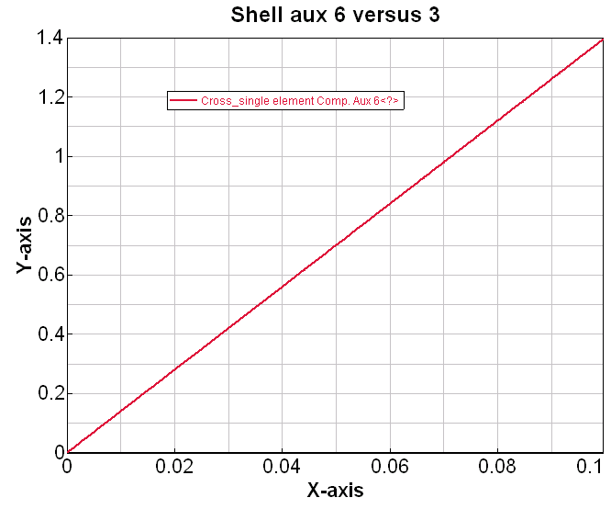
which is the same as the ply homogenised input value.

Part 3: Calibration of the orthotropic damage and failure properties

Tension (and compression) fibre failure
Using dataset Mat131_TensionX_FibreFailure.pc and the results files.
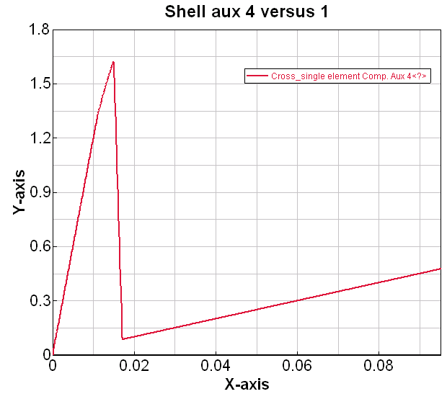
First fibre failure is defined. This is calibrated against a coupon test that measures tension fibre failure (i.e. a uni-axial 0° tension coupon test). For compression properties an identical calibration is followed fitted to a uni-axial 0° compression coupon test.
Damaged intermediate slope = (1.0 - 0.1) * Eo

The following data is obtained from test measurements. Strains for limit linear behaviour, ultimate load and final rupture are 0.011, 0.015 and 0.017 respectively. The intermediate and final damages are 0.1 and 1.0.
Residual matrix strength – fibres are fully damaged

Create a cross plot time history of shell element Aux4 versus Aux1 for element stress11 versus element strain11 in the fibre frame. At inter-mediate strain (0.015) the modulus is damaged by 10% (0.1). Thereafter the fibres rapidly damage to ultimate failure at 0.017 strain. The progressive rupture is useful in a simulation to steady damage evolution and helps damp the solution. The residual elastic stress shown is the matrix contribution which is not damaged in this data set.

Shear loading for matrix shear failure
Using dataset Mat131_ShearXY_MatrixShearFailure.pc and the results files.

Matrix shear damage is now defined. This would be calibrated against a coupon test that loads the composite for intra-ply matrix shear failure (e.g. axial loading of a ±45° coupon). In this case matrix damage is controlled by shear strains and shear damage data.
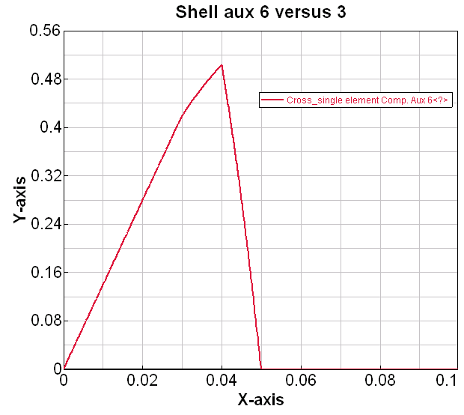
For this example matrix ‘tensor’ shear damage strains (tension and compression) are set to 0.03, 0.04 and 0.05 with intermediate and final damage 0.1 and 1.0 respectively.

Create a cross plot time history of shell element Aux6 versus Aux3 for element stress12 versus element strain12 in the fibre frame. The undamaged, partial damage and final rupture zones are visible between shear strains 0.→0.03, 0.03→0.04 and 0.04→0.05 respectively; final matrix failure occurs at strain 0.05.

Note: The Bi-phase model also allows hydrostatic matrix damage. This is difficult to test and unlikely to happen in practice. It is therefore easiest to test and calibrate only shear damage and leave hydrostatic damage deactivated (set to zero).
Fibre direction tension (tensile fibre and shear failure)
Using dataset Mat131_TensionX_FibreFailure+MatrixShearFailure.pc and the results files.
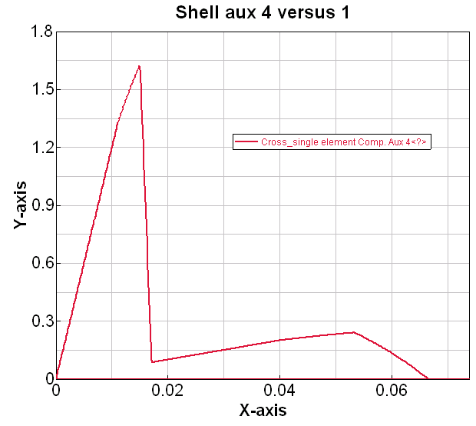
In this dataset the previous fibre and matrix failure data are combined. Loading is tension in the fibre direction.

Create a cross plot time history of shell element Aux4 versus Aux1 for element stress11 versus element strain11 in the fibre frame. Results show that fibre failure occurs first (due to the lower failure strain assigned), followed by matrix rupture.

Note: Experimental testing may not show this post-fibre failure response. However, the model is only a idealisation and importantly tests are conducted under load control, whereas the simulation is velocity/displacement loaded; these two loading conditions do create different post failure behaviours.

Transverse matrix failure in tension
Using dataset Mat131_TensionY_Failure.pc and the results files.
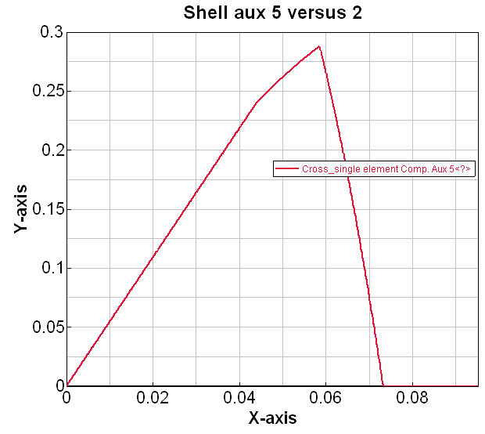
Transverse matrix failure should be checked against results from a 90° tension test. In this study the combined matrix (shear) and fibre failure data are used with the element loaded in transverse tension.

Create a cross plot time history of shell element Aux5 versus Aux2 for element stress22 versus element strain22 in the fibre frame. Results show the matrix shear failure data is able to reasonably represent matrix failure under tension loading.

Note: A limitation of the Bi-Phase model is that matrix normal (tension or compression) failure and matrix shear failure cannot be decoupled; they are linked via the strain invariant failure criteria.

Remarks:
- For the complete composite material model all data should be combined for mechanical stiffness, fibre failure and matrix failure; for both tension and compression.
- It is straightforward to assign different mechanical and failure data for tension and compression. Composites are generally weaker in compression and this can be easily treated.
- The fibre directions can be visualized. Load the .pc file into Visual-Crash and click on Checks > Display fibre orientations.
- Auxiliary variables 11, 12 and 13 give other useful output for total, shear and volumetric damage; auxiliary 15 is fibre damage. These variables are available for contour and time history plots.

Part 4: Alternative options for damage and failure
Damage curve functions
For fibre damage, and matrix shear and hydrostatic damage the shape of the damage curve has so far been defined using initial, intermediate and final strain values together with intermediate and final damage values. The model assumes parabolic curves between points and can reasonably fit mildly non-linear behaviour. However, the fit becomes difficult for large strain non-linear behaviour.

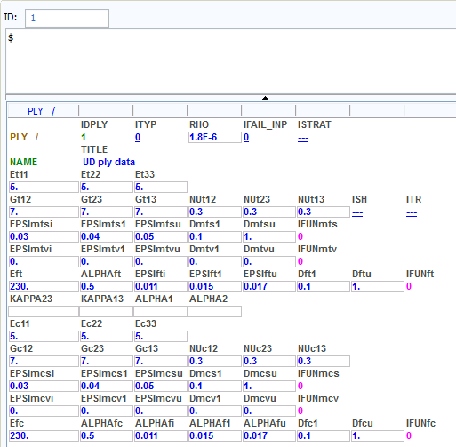
For this reason alternative damage evolutions via curve functions (IFUNxxx) are possible. The curves are damage [=i.e. (1-E_{D}/E_{O}) or (1-G_{D}/G_{O})] versus strain.

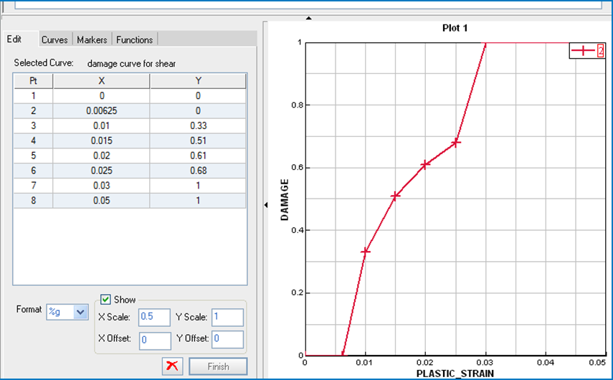
A typical damage curve function is shown (x is strain information and y is damage information). The curve starts at zero with an initial undamaged zone for linear behaviour. The final damage in this case reaches 1.0. In this case 5 points on the test stress-strain curve have been selected to construct the damage function curve.

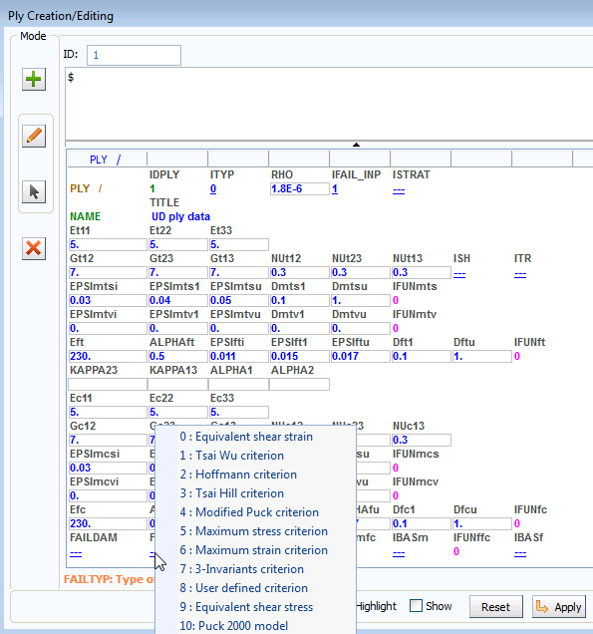
Superimposed failure criteria
If fibre (or matrix) damage reaches 1.0 then that constituent is fully damaged and offers no resistance to loading; the other constituent can carry loading until it is fully damaged.

In addition it is also possible to superimpose other failure criteria such as Tsi-WU, Max. stress, etc. Set IFAIL_INP=1 and choose the failure criteria with flag FAILTYP. Depending on the selected failure criteria additional failure information is required.

If the state of stress or strain reaches the failure criteria the element will be eliminated (if FAILDAM = 1). In the materials cards the IFAIL option must also be set.

Part 5: Specific information for woven reinforcement (Mat 131 ply type 8)

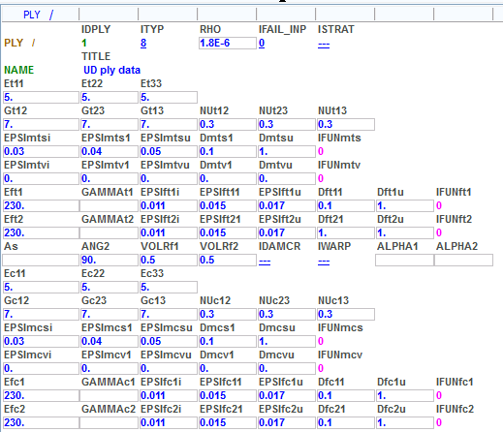
The data shown is typical information for ply type 8. Some points to note are:
- The structure and general information required is similar to ply type 0
- IMPORTANT: Fibre volume ratios are used in the LOM to get E11 (using VOLRf1) and E22 (using VOLRf2).
- Main fibre direction 11 is with respect to the reference axis defined in the Part cards and the angle in the Materials cards. The second fibre direction is by default at 90°, or as specified by ANG2.

