Model calibration

Composite Global Ply model 131 for elastic, damage and failure

- PAM-CRASH material model 131 is for multi-layered composite shell elements.
- Within this model different ply types can be used for different fibre reinforcements and damage laws. This document covers the ESI composite Global Ply damage law for:
- Ply type 1 for uni-directional composites (shell elements only).
- Ply type 7 for woven type composites (shell elements only).
- The Global Ply law is not available for solid elements.

Problem description
Outline | Application of the ‘Global Ply’ composite damage model to a single element under various loadings
Analysis type(s): | Explicit
Element type(s): | Applicable to shell elements (material model 131)
Materials law(s): | PAM-CRASH material model 131 (composite ply types 1 and 7). Fibre and matrix are calibrated for:  - Orthotropic elasticity  - Orthotropic fibre and matrix damage with failure
Model options: | Boundary conditions, Imposed velocity loads, Composite materials
Key results: | Outputs for composites (fibre stresses and strains, matrix damage, fibre orientations… )
Prepared by: Date: | Anthony Pickett, ESI GmbH/Institute for Aircraft Design, Stuttgart September 2012

Background information

Pre-processor, Solver and Post-processor used:
- Visual-Crash PAM: To assign material, loading, constraint and control data.
- Analysis (PAM-CRASH Explicit): To perform the explicit Finite Element analysis.
- Visual-Viewer: To evaluate results for contour plots, stresses and strains, etc.

Prior knowledge for the exercise
It is assumed the user has some knowledge of Visual-Crash PAM and PAM-CRASH.
Problem data and description
Units: kN, mm, kg, ms
Description: Single shell element 10mm * 10mm and 1mm thick
Loading: Imposed constant velocity at 1mm/msec (duration of study 1msec) ⇨ total displacement 1mm and strain 0.1 (= 10%)

Loading cases:
1
2
3
4
1
x
y

Case 1: Axial fibre Case 2: Transverse matrix Case 3: Shear loading

Material: The material to be analysed is a high performance balanced woven fabric composite. The data is presented from mechanical testing in the exercise.
Supplied datasets
All completed datasets are supplied. The main aim is to demonstrate the strategy for model calibration which is done here using the shell element (material model 131, ply type 1).
Calibration for orthotropic elastic properties:
Fibre direction in tension Mat131_TensionX_Elastic.pc
Fibre direction in compression Mat131_CompressionX_Elastic.pc
Shear loading Mat131_ShearXY_Elastic.pc
Calibration for damage, plasticity and failure:
Fibre direction in tension (fibre failure) Mat131_TensionX_ElasticFibreFailure.pc
Fibre direction in compression (fibre failure) Mat131_CompressionX_ElasticFibreFailure.pc
Shear loading (elasto-plastic shear) Mat131_ShearXY_ElasticDamageFailure_Option1_Plastic.pc
Shear loading (elasto-plastic shear) Mat131_ShearXY_ElasticDamageFailure_Option2_Plastic.pc
Shear loading (elasto-plastic shear) Mat131_ShearXY_ElasticDamageFailure_Option3_Plastic.pc
Cyclic loading (elasto-plastic shear) Mat131_ShearXY_ElasticDamageFailure_Option3_Plastic_Cyclic.pc
Comments concerning ply types 1 and 7
Two ply types are available that use the Global ply damage law for UD and woven type composites:
- Ply type 1 is intended for UD composites, but can also be used to approximate a woven fabric by stacking two UD layers with appropriate fibre angles and distribution of mechanical properties. Indeed, it can be advantageous for non-orthogonal reinforcement (e.g. ±30°) and cases where large intra-ply shear strains occur.
- Ply type 7 is for woven fabrics and mostly suited to orthogonal reinforcement and applications where shear strains are small. The following table summarises these three cases.

Option /  Ply type | Representation | Comments
1  (Ply type 1) |  | Standard representation for UD composite plies
2  (Two layers of Ply type 1) |  | - The woven composite is idealised as two stacked plied of ply type 1  - In plane and shear properties must be carefully distributed between plies  - Useful for non-orthogonal reinforcement and large shear loading
3  (Ply type 7) |  | Standard representation for woven composite plies:  - Ideally for orthogonal reinforcement  - Intra-ply shear strains should not be large

This document demonstrates the calibration strategy for option 2 in the above table applied to a ‘balanced’ woven fabric composite. Actual tests results are used in this calibration. The methods used are identical if standard ply types 1 or 7 are used.

Basic theory
A full description of the Global ply model is given in the original reference and also in the ESI PAM-CRASHTM user’s manual.
Essentially the fibre phase uses a strain based failure criteria for tension and compression; non-linear (elastic) behaviour is possible in compression and is often necessary to account for micro-buckling effects in compression. The shear behaviour uses a coupled damage and plasticity model that accounts for modulus reduction and permanent plastic deformations. The fibre and matrix laws are decoupled, but parameters are available that allow coupling of transverse and shear matrix damage.

Part 1: Some basic explanation of the input data

Typical model loadings and supports (e.g. for dataset Mat131_TensionX_Elastic.pc)
Load the dataset into the Visual-Crash Program (VCP) and study the supports and the loading:
1
2
3
4
x
y

- In Loads > Displacement Boundary Condition the following
definitions are found:
- Node 1 is fully constrained.
- Node 2 is fully fixed, except free in the x-direction.
- Node 4 is fully fixed, except free in the y-direction.

2. In Loads > 3D BC nodes 2 and 3 are loaded at constant velocity
in the positive x-direction (for tension fibre loading).
Remark: This simple setup ensures the element is properly supported and has pure tension loading in the x-direction with free contraction in the y-direction.
Ply, Material and Part data cards
Note from the dataset:
- The parts data contain information on geometric data such as the reference fiber orientation. A link to associated material data (variable IMAT) is also made.
- The materials cards (IMAT) contain information on density, the number of plies in the laminate and the stacking sequence. Within this stacking sequence information on each ply, including the reference ply set (parameter IDPLY), the ply thickness and a fibre orientation angle are defined.
- The ply cards (IDPLY) contain all ply mechanical data for stiffness, damage and failure.

Considering the sequence in which the data refers to each other (1→2→3) it is best to define things in reverse order; i.e. the plies first, then materials and finally parts; all three are needed.

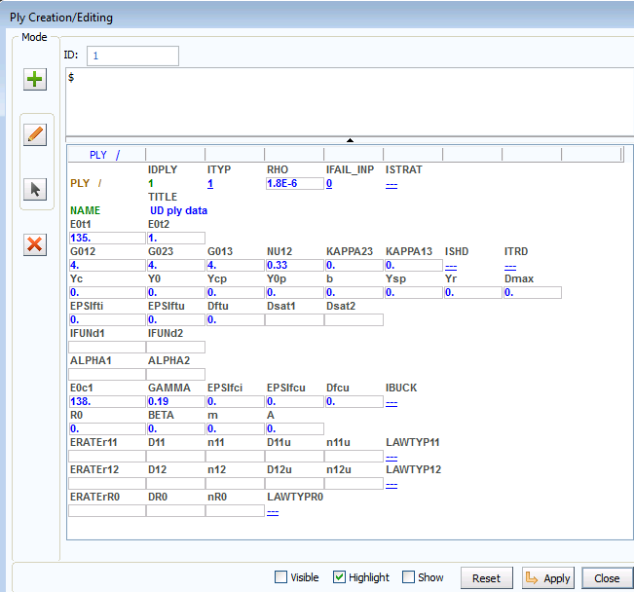
Ply cards
(e.g. Ply properties for dataset TensionX_Elastic.pc).

In the ply cards you will find the mechanical, damage and failure data assigned to the ply.
- IDPLY is the ply identification number and ITYP is the ply type (1 or 7).
- The mechanical data (density, modulus, shear and Poison’s ratio) are given on the first cards. This is then followed by failure, compression, plasticity and strain rate data.
- Note: Contrary to the PAM-CRASH Bi-phase model all mechanical data represents homogenised properties.
Material cards
(e.g. Material properties for dataset TensionX_Elastic.pc).
- The number of plies in the laminate are defined (NOPLY) and for each ply the associated ply number (IDPLY), the ply thickness (THKPL) and fibre angle (ANGPL) are defined. Note the fibre angle is with respect to a reference vector defined in the Parts cards (see below) and that two stacked plies are defined.
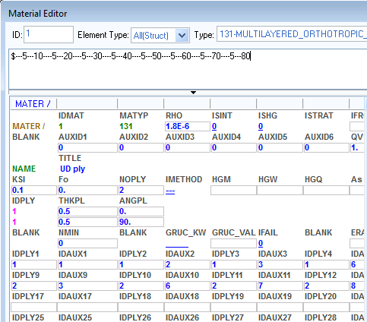
- Special output results to the .THP and .DSY files (or .ENF file if used) are possible such as fiber, transverse and shear stresses/strains. For this the ply number in the laminate lay-up and an auxiliary reference number for the variable to be output are given. Examples of auxiliary reference numbers are Aux’s 1-3 for fibre strain11, strain22 and shear strain12, and Aux’s 6-8 for corresponding fiber stresses. Auxiliary reference numbers are also available for results such as fibre and matrix damage.
Part cards
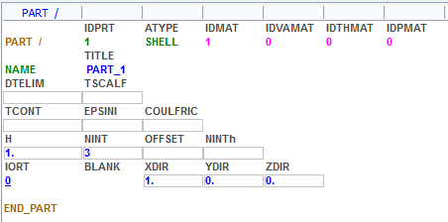
(e.g. Part properties for dataset TensionX_Elastic.pc).
- The connection to the associated material is made via the IDMAT number (in this case = 1).
- A vector for the reference fibre direction is defined. Here the global vector option with a reference vector 1,0,0 (i.e. the global x-direction) is used. For shell elements the transverse direction is normal to the fiber direction in the element plane.

Part 2: Determination of orthotropic elastic and failure properties from test measurements
In this exercise test results are first presented from which the necessary material properties for stiffness and failure are extracted. The model and input data are then validated using a single element test case.
For the woven fabric composite the tests needed to extract data are:
1. Tension test on 0° specimens ⇒ elastic and failure properties
2. Compression test on 0° specimens ⇒ elastic and failure properties
3a. Shear elastic properties (Tension test on a ±45° specimen)
3b. Shear damage properties (Cyclic tension test on a ±45° specimen)
3c. Shear plasticity properties (Cyclic tension test on a ±45° specimen)

1. Tension test on 0° specimens: Elastic and failure properties
Four test coupons loaded in the 0° direction (=90° direction for a balanced woven fabric composite) are shown. For a simple coupon:

and

by definition ⇨

There is some scatter in the test data; but reasonable averages for stiffness and failure data are summarised in the table below.

Property | Value
$E_{1}^{0t}$ Tensile elastic modulus (fibre direction) | 67.5 GPa
$σ_{i}^{\text{ft}}$ Tensile failure stress (fibre direction) | 880 MPa
$ε_{i}^{\text{ft}}$ Tensile failure strain (fibre direction) - initiation | 0.013
$ε_{u}^{\text{ft}}$ Tensile failure strain (fibre direction) - ultimate | 0.0131
$d_{u}^{\text{ft}}$ Assumed ultimate damage (fibre direction) | 1.0

2. Compression test on 0° specimens: Elastic and failure properties

In this case $E_{1}^{0C}$is given by the initial slope of the compression stress-strain curve (dashed line); e.g.
test
$E_{1}^{0C}$≈ 400 / 0.00575 GPa
= 69.0 GPa.

All other failure data is estimated and given in the table below.

Property | Value
$E_{1}^{0t}$ Compression elastic modulus (fibre direction) | 69.0 GPa
$σ_{i}^{\text{ft}}$ Compression failure stress (fibre direction) | 650 MPa
$ε_{i}^{\text{ft}}$ Compression failure strain (fibre direction) - initiation | 0.0104
$ε_{u}^{\text{ft}}$ Compression failure strain (fibre direction) - ultimate | 0.0105
$d_{u}^{\text{ft}}$ Ultimate compression damage (fibre direction) | 1.0

A further useful parameter in compression is the corrective parameter (γ) to help approximate the nonlinear compression curve (due to fibre crimp and micro-buckling). This is given by,
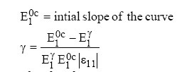

.
Performing this computation about an arbitrary point ( e.g. strain ε₁₁ = 0.008) gives γ = 0.17

3a. Shear elastic properties (Tension test on a ±45° specimen)
For the elastic shear data the initial (undamaged) portion of the tensile loaded cyclic shear test is used; an example for the woven fabric is given below. The stress-strain relations in the fibre frame are defined as follow:
and
Gº₁₂ is given by the initial slope of the shear stress (σ₁₂) versus the engineering shear strain (2ε₁₂).

ε₁₂
σ₁₂ (GPa)

The initial shear modulus is defined as the initial slope of the test curve (remembering that engineering shear strain must be used (γ₁₂=2ε₁₂),
Gº₁₂ = σ₁₂ / 2ε₁₂ = 60 / (2*0.0075) = 4.0 GPa.

3b. Shear damage properties (cyclic tension test on a ±45° specimen)
The previous cyclic shear test for tensile loading of a ±45° coupon is used to extract damage evolution, plasticity and final shear failure data. Shear damage is given by the change in slope of the cyclic modulus G_{12i} and plasticity by the growth in ε_{ip} and each loading cycle i.

Five loading cycles have been performed on the coupon as shown in the next curve. Note that this figure shows test results with, and without, taking account of changes in cross sectional area in the computation of σ₁₂. If these changes can be measured during testing and included then the model calibration will be more accurate. The curve with section variation is used here.

At each cycle the stiffness loss is characterised by the shear modulus reduction. The degree of shear damage d₁₂ is given by the relationship:
$$d_{{}_{\text{12}}}^{i}=1−\frac{G_{\text{12}}^{i}}{G_{\text{12}}^{0}}$$
Shear modulus and damage values for every cycle are summarised in the table below; again using engineering shear strain (γ₁₂=2ε₁₂) to calculate the G values,

cycle | Shear modulus G₁₂ | d₁₂
0 | 4.0 | 0
1 | 3.914 | 0.1027
2 | 3.302 | 0.2430
3 | 2.453 | 0.4376
4 | 2.255 | 0.4830
5 | 2.237 | 0.4872

This model uses the term Y12 to define how damage is progressing (it is the change of stored elastic energy with damage). The stored energy for a ply is,
Considering only stored energy for shear (12) the conjugate quantity Y₁₂ is
$$Y_{\text{12}}=\frac{δ E_{D}}{δ d_{\text{12}}}|_{σ}=\frac{1}{2}\frac{σ_{{\text{12}}^{2}}}{G_{\text{12}}^{0}(1−d_{\text{12}})^{2}}$$
From $ε_{\text{12}}=\frac{σ_{\text{12}}}{2G_{\text{12}}^{o}(1−d_{\text{12}})}$ ➢ $Y_{\text{12}}=\frac{1}{2}G_{\text{12}}^{0}(2ε_{\text{12}}^{e^{i}})^{2}$

A similar expression to Y₂₂ could be developed for UD plies where damage will occur in the unreinforced transverse direction; however this is not needed here for the woven fabric. The conjugate force quantity at each cycle (i) is therefore given by,

$Y_{{}_{\text{12}}}^{i}=\sqrt{\frac{1}{2}G_{{}_{\text{12}}}^{0}(2ε_{\text{12}}^{e^{i}})^{2}}$.
From the cyclic test curve and the above expression,
cycle | $$ε_{\text{12}}^{e}$$ | Y_{i}
0 | 2.00E-03 | 0.005656
1 | 5.10E-03 | 0.015064
2 | 9.60E-03 | 0.028355
3 | 1.70E-02 | 0.050212
4 | 2.45E-02 | 0.072364
5 | 2.95E-02 | 0.087132
It is now possible to plot the evolution of Y₁₂ with damage d₁₂.
cycle | Y_{i} | d₁₂
 | 0 | 0
0 | 0.005656 | 0
1 | 0.015064 | 0.1027
2 | 0.028355 | 0.2430
3 | 0.050212 | 0.4376
4 | 0.072364 | 0.4830
5 | 0.087132 | 0.4872
The damage is initially linear (for small strains and then increases rapidly close to failure), as shown in the adjacent plot. Several options are available in PAM-CRASH to characterise damage evolution; for example, an exponential function, a curve function and the following (original) linear damage function,

$Y_{\text{12}}^{i}=Y_{C}×d_{\text{12}}^{i}+Y_{0}$,

where Yo is the initial constant and Yc is the slope of the linear function. A further parameter YR is used to specify failure (Yo, Yc and YR are data input values for PAM-CRASH shear damage evolution and failure).

Two examples to try and fit the linear function to the test curve are shown in the graph with data in the table below; clearly this is not accurate. For this ductile matrix the exponential or curve function methods would be better.

 | Y_{O} | Y_{C} | Y_{R}
Lin. Function 1 | 0.005 | 0.1014 | 0.05
Lin. Function 2 | 0.0004 | 0.1464 | 0.07
Curve function | Using the data points in the table above |  | 0.088

3c. Shear plasticity properties (Cyclic tension test on a ±45° specimen)
The inelastic deformation is described by a plasticity law which couples transverse (22) and shear (12) strains only. The plastic strain p_{j} is the measure of effective plastic strain and the term R_{i} is used to determine how the value of d₁₂ affects the yield stress in each cycle.
In this model the terms “effective stress” and “effective strain” are introduced as measures of actual material stress and strain carried by the damaged material. The damage (micro-cracking) reduces the “effective” area of the load carrying material causing effective material stress to be raised and effective material strain to be lowered. Note this terminology is not the same as Von Mises effective stress and strain which is commonly used in plasticity in the literature.
The term p_{j} and R_{i} are calculated in the following equations:

$\left.\begin{matrix}p_{i}=\int_{ε_{\text{12}}^{p^{i−1}}}^{ε_{\text{12}}^{p^{i}}}{2(1−d_{i})ε_{\text{12}}^{p}} \\ P_{j}=\sum_{i=1}^{i=j}{p_{i} } \\ R_{i}=\frac{σ_{\text{12}}^{i}}{1−d_{i}}−R_{0} \end{matrix}\right\}⇒R_{i}=β(P_{j})^{m}$ (Eq 1.)
$1≤i,j≤\text{number of cyclic loads}$

where ε₁₂^{P} is the plastic strain at each cycle i, as shown on figure below. The following table gives the plastic strain measured from the cyclic shear test curve and the damage term which are used to calculate pi. According to Equations 1 a plot of 1-d₁₂ versus 2ε₁₂^{P} allows the (p_{i}) values to be found by integration for each cycle. The values for (P_{j}) are then computed from summation of these values. The following curve and table summarise results of this integration and the summation.
cycle | $$ε_{\text{12}}^{p}$$ | 1 - d₁₂
0 | 0 | 1
1 | 7.24E-04 | 0.897295
2 | 4.90E-03 | 0.756992
3 | 1.77E-02 | 0.562357
4 | 4.75E-02 | 0.516965
5 | 8.45E-02 | 0.512838

p₂
p₅
p₄
p₃

Cycle | p_{i} | P_{j} | R_{i} (MPa)
0 | 0 | 0 | 0
1 | 0.001448 | 0.001448 | 0.026362
2 | 0.007494 | 0.008942 | 0.065272
3 | 0.019379 | 0.028321 | 0.129727
4 | 0.033516 | 0.061838 | 0.193748
5 | 0.038255 | 0.100093 | 0.239731

Finally, a curve fitting exercise is performed to fit the PAM-CRASH exponential plasticity function (with parameters β and m) to the Ri versus Pi curve. This has produced the following results with the initial plasticity yield stress Ro = 20MPa.

P_{j}

Part 3: Summary of the Global Ply dataset for elastic, damage, plasticity and failure
For the purpose of this calibration a total ply thickness of 1.0mm is assumed meaning that each ply in the stacked approximation is 0.5mm (Make sure the true value is used in any real composite).
In order to compensate for the halved ply thickness in this idealised model:
- Double the modulus for tension and compression modulus.
- Use unchanged shear modulus (and shear damage/plasticity) for each ply.
- Use a low modulus (say 1GPa) for the transverse direction (to minimise interaction effects).

Note: Any modifications to ply modulii will correspondingly modify the stress levels; however, damage and failure is always controlled by strain and therefore the approach (to treat a woven composites as two stacked UD plies) is valid.

The following table summarises the data so far for each ply (thickness = 0.5mm) in the idealised woven composites.

Inplane Tension | Inplane Compression
$E_{1}^{0t}=$(2*67.5)=135 GPa | $E_{1}^{0c}=$(2*69,0)=138 GPa
$E_{2}^{0t}=$1.0 GPa | $γ=$0.17
$ν_{\text{12}}^{0}=$0.33 | $ε_{i}^{\text{fc}}=$0.0104
$ε_{i}^{\text{ft}}=$0.013 | $ε_{u}^{\text{fc}}=$0.0105
$ε_{u}^{\text{ft}}=$0.0131 | $d_{u}^{\text{fc}}=$1.0
$d_{u}^{\text{ft}}=$1.0

Table 1: Inplane stiffness/failure data

For the shear the following data/options were determined (to be used for each ply):
Stiffness | G ^{O} ₁₂ = 4.0 GPa
Damage | Yo | Yc | YR
Lin. Function 1 | 0.005 | 0.1014 | 0.05
Lin. Function 2 | 0.0004 | 0.1464 | 0.07
Curve function | Using the Y12-d12 data points |  | 0.089
Plasticity | $$R(P_{j})=0\text{.}\text{7986}P_{j}^{0\text{.}\text{5166}}$$
 | ⇒$R_{0}$= 20MPa, β = 0.7986, m = 0.5166
Table 2: Shear stiffness, damage and plasticity data

Part 4: Checking the input with simulation results

Simulation results
Fibre tension (elastic without and with failure)
Using dataset: Mat131_TensionX_ElasticFibre.pc (for no failure)
Mat131_TensionX_ElasticFibreFailure.pc (for fibre failure)
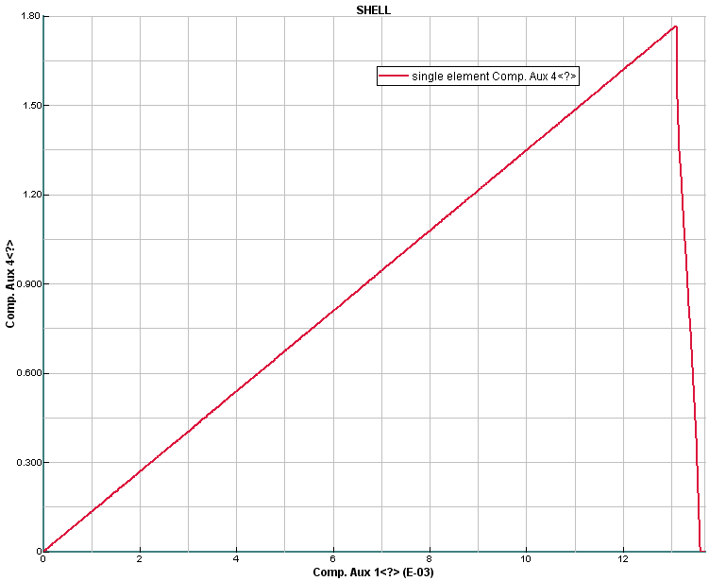
Positive x-velocity is applied to nodes 2,3 (0.1mm/sec) (= Case 1, Pg 2)..
Fibre tension (for the failure case)
The shell element time history plot Comp. Aux4 (fibre stress) against Aux1 (fibre strain) is plotted for the fibre direction ply. For a strain of 0.01 the corresponding fibre direction stress is ≈1.35GPa; note:
- This stress is (≈ correctly) double that of the test value (700N/mm2 at 0.01 strain) since the equivalent ply thickness is half of the true woven ply. The difference is due to the small contribution from the transverse direction in the second ply; calibration could be done to correct this.
- The failure data $ε_{i}^{\text{ft}}=$0.013, $ε_{u}^{\text{ft}}=$0.0131 and $d_{u}^{\text{ft}}=$1.0 is imposed. In this case tensile fibre failure is initiated at the required 1.3% strain and full damage occurs (d=1.0).
- If a residual damage is required use d<1.0. E.g. for d=0.3 only 30% of damage occurs (Edamage = 0.7 * Eo) and the stress will remain constant after this damage state is reached.

Results: fibre compression
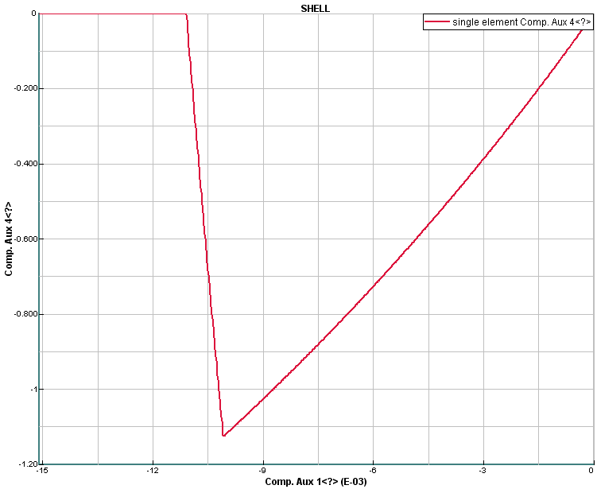
Using dataset: Mat131_CompressionX_ElasticFibre.pc (for no failure)
Mat131_CompressionX_ElasticFibreFailure.pc (for fibre failure)
Negative x-velocity (=-0.1mm/sec) is applied to nodes 2,3..
Fibre compression (for the failure case)
- The nonlinear form of the compression fibre stress (Aux 4) versus fibre strain (Aux 1) is evident due to the factor γ = 0.17.
- Stress in the fibre ply (x-direction) is approximately twice the test value due to the previously mentioned reason; for example, at fibre strain 0.09, the simulation stress is 1.02kN compared to test 0.54kN.
- The failure data $ε_{i}^{\text{fc}}=$0.010, $ε_{u}^{\text{fc}}=$0.011 and $d_{u}^{\text{fc}}=$1.0 is imposed. Failure is initiated and completed, as expected, with total damage due to d=1.0.

Transverse direction (= Case 2, Pg 2)
Since this composite has a balanced fabric the second ply transverse direction will have the same properties as the fibre direction calibrated above. This is assured in the dataset using 2 layers for the model with identical properties for layer 1 (in the 0°) and layer 2 (in the 90°).

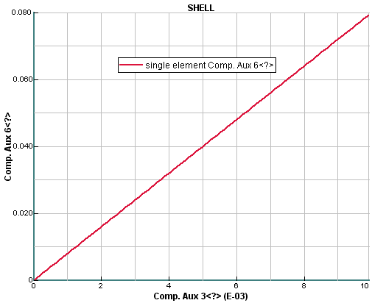
Shear (for the elastic case using dataset - Mat131_ShearXY_Elastic.pc)
The single element test case is loaded in the positive x and negative y directions to impose pure shear loading (= Case 3, Pg 2). The fibre directions are set to ±45° with respect to the x-direction.
A time history plot of shear stress σ₁₂ (Aux6) against shear strain ε₁₂ (Aux3) is shown. At 0.0075 shear strain the shear stress is 60MPa; which corresponds to the value of the initial slope of the experimental shear stress versus shear strain curve.

Shear (for the damage with failure plus plasticity)
Shear damage can be treated using the linear damage function, an exponential function or the curve function; ultimate shear failure is specified by the value of YR. The previous table for shear damage evolution and failure is repeated below with the three options (1, 2, 3) evaluated here to compute shear damage. In each case the previously determined plasticity data is used.
 |  | Shear damage data |  |  | Plasticity data
Option | Damage function | Yo | Yc | YR | Ro | β | m
1 | Lin. Function 1 | 0.005 | 0.1014 | 0.05 | 20 MPa | 0.7986 | 0.5166
2 | Lin. Function 2 | 0.0004 | 0.1464 | 0.07 | 20 | 0.7986 | 0.5166
3 | Curve function | using the data points in the Y12-D12 table |  | 0.089 | 20 | 0.7986 | 0.5166

The three supplied datasets for the above cases are:
- ShearXY_ElasticDamageFailure_Option1_Plastic.pc
- ShearXY_ElasticDamageFailure_Option2_Plastic.pc
- ShearXY_ElasticDamageFailure_Option3_Plastic.pc

Using the linear shear function (options 1 and 2): For some semi-brittle materials the linear fit may be satisfactory; but in this case the fit is poor, especially to describe the rapid damage growth at large shear strains. The following curves illustrate the poor fit of the linear function to the test (damage) curve and the correspondingly poor correlation of the single element analysis to the test shear stress-strain curve.

Using the curve shear function (option 3)
In PAM-CRASH (version V2008+) exponential and curve descriptions for shear and transverse damage evolution are available. In the Option 3 dataset the ‘Linear’ parameters for Yo, Yo’ are removed and the variable ISH is set to 2. A curve description of Yi against d12 is used with the previously determined data (note the 0,0 start point) in an auxiliary curve; set this curve number to the parameter ICURV1 in the ply data. The ultimate shear strain parameter YR is set to 0.089.
From the results a plot of shear stress (Aux 6) against shear strain (Aux 3) shows a good agreement with the test curve for both shape and failure; although some improvements using more data points could help to smooth the shape, especially at shear strain 0.04.
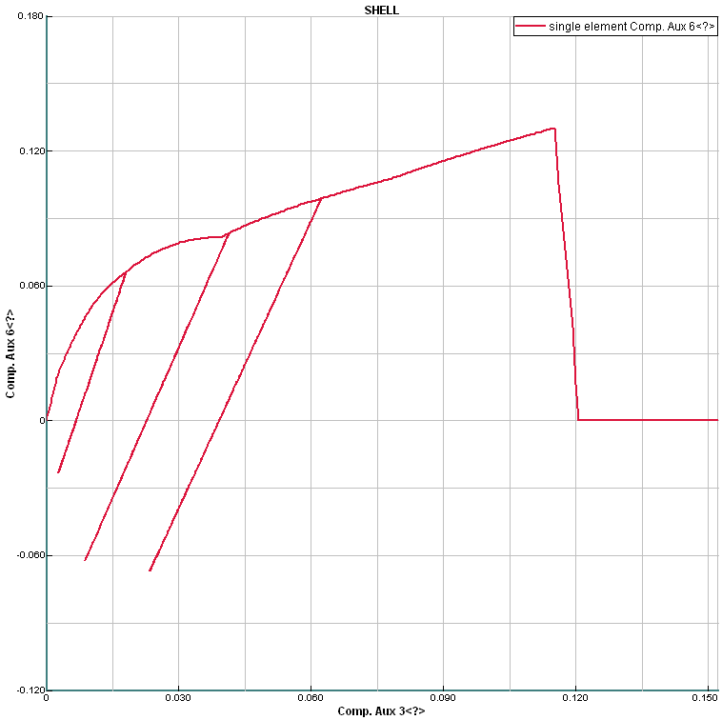
Cyclic shear loading
Using shear damage (option 3) and the dataset
ShearXY_ElasticDamageFailure_Option3 _Plastic_Cyclic.pc

The adjacent plot shows cyclic (velocity) loading of the single element test case. The change in slope of the unloading curve represents damaged shear modulus. Also, the inelastic (permanent) plastic strains are evident.

Part 5: Alternative options for damage and failure
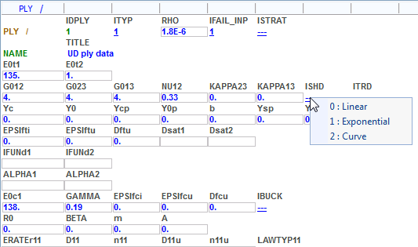
Damage curve functions
Different methods can be used to define the form of the damage functions; namely, Linear, Exponential or Curve. For most composites an exponential or Curve function will be needed to reasonably describe the damage function evolution.

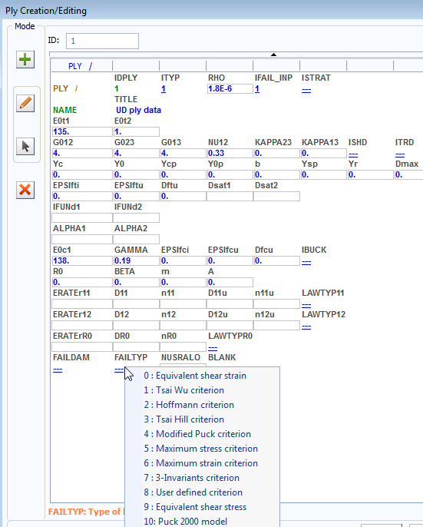
Superimposed failure criteria
For fibre and matrix damage the Global ply model has so far been used. However, it is also possible to superimpose a classical failure criteria such as Tsai-Wu, Max. stress, etc.

Set IFAIL_INP=1 and choose the failure criteria with flag FAILTYP. Depending on the selected failure criteria additional failure information is required. If the state of stress or strain reaches the failure criteria the element will be eliminated (for FAILDAM = 1). In the materials cards the IFAIL option must also be set.

Part 6: Specific information for woven reinforcement (Mat 131 ply type 7)
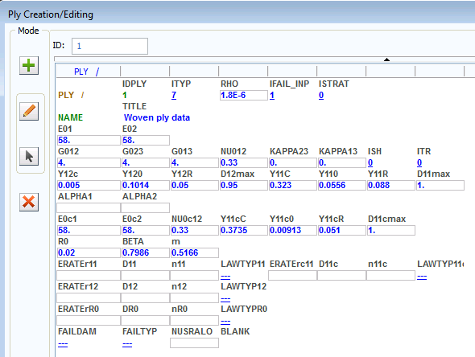
The data shown is typical information for ply type 7. Some points to note are:
- The structure and general information required is similar to ply type 1.
- The two main fibre directions are assumed to be orthogonal.
- Tension and compression information is provided for the main fibre direction (E01, E0c1) and the second fibre direction (E02, E0c2).
- For tension fibre failure driving force values YIIC, Y110 and Y11R are used, for compression YIIcC, Y11c0 and Y11cR are used. Note that currently this information is applied to both reinforcement directions, so strictly the fabric should be balanced (i.e. E01 = E02 and E0c1 = E0c2).
- Strain rate can be applied.

Ladevèze P, Le Dantec E, “Damage Modelling of the elementary ply for laminated composites”, Composites Science and Technology, Vol. 43, Issue 3, 1992, pp. 257-267.
PAM-CRASH™ Users manuals, Engineering Systems International, 20 Rue Saarinen, Silic 270, 94578 Rungis-Cedex, France. www.esi-group.com

