Tutorial 1 and 2

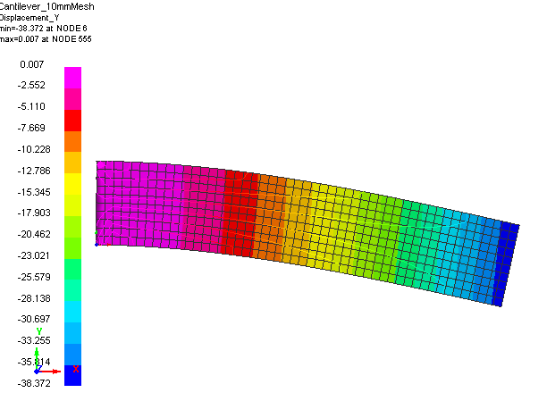
End Loaded Cantilever and Shell Element Studies

Problem description
Outline | An end loaded ‘built in’ cantilever beam is analysed to demonstrate different analysis types (implicit and explicit) and different shell element types available in PAM-CRASH
Analysis type(s): | Implicit and Explicit, 2D analysis
Element type(s): | Shell: Quadrilateral (Belytchko-Tsay, Hughes-Tezduyar), Triangle (Belytchko-Tsay)
Materials law(s): | Elastic
Model options: | Boundary conditions, Nodal loads, Nodal damping, Hourglassing
Key results: | Displacements, Convergence
Prepared by: Date:  Version: | Anthony Pickett, ESI GmbH/Institute for Aircraft Design, Stuttgart November 2007  V4 (Updated May 2012 for Visual-Crash PAM V8.0)

Background information

Pre-processor, Solver and Post-processor used:
- Visual-Mesh: For generation of the geometry and meshes.
- Visual-Crash PAM: To assign control, material data, loadings, constraints and time history (control) data.
- Analysis (PAM-CRASH Explicit and Implicit): To perform the Finite Element (FE) analyses.
- Visual-Viewer: Evaluating the results for contour plots, deformations, etc.

Prior knowledge for the exercise
No prior Visual or PAM-CRASH knowledge is required for working through this exercise.
Problem data and description
Units: kN, mm, kg, ms
Description: Plate 250mm*50mm, thickness 2mm
First analyse using a regular 10*10mm quadrilateral mesh (this will later be refined
30kN
to 5*5mm and 2.5*2.5mm for the convergence study).
50
250
Loading: Imposed total load = 30kN (this is to be distributed at the loading end)
Material: Steel (E=210kN/mm², ν=0.3 and density 7.8*10⁻⁶kg/mm³)
Supplied datasets
No datasets or meshes are needed to tackle the problem; the mesh will be generated as a part of the exercise.
It is recommended that you use the following names for the PAM-CRASH input and results files:
For the elastic cantilever 10 mm mesh use Cantilever_10mmMesh.pc
For the elastic cantilever 5 mm mesh use Cantilever_5mmMesh.pc
For the elastic cantilever 2.5 mm mesh use Cantilever_2.5mmMesh.pc
In each case completed PAM-CRASH datasets are available in case you get into trouble.
Background information: Solution methods and geometry
Implicit versus explicit analysis: The PAM-CRASH code is a general purpose three dimensional (3D) code for implicit and explicit FE analysis. This exercise performs implicit and explicit analyses of a simple two dimensional (2D) structure with applied force loading.
Explicit analysis treats the structure as a dynamic problem and solves dynamic equations of motion in the time domain; it is especially efficient to solve crash, impact and similar dynamic problems, particularly if material non-linearity (plasticity..), large deformations or contact occur. For explicit analysis you will find all nodal and element quantities given with respect to time.
Implicit analysis (usually) assembles the structure stiffness matrix to solve static loading problems that are independent of time. Material non-linearity, large deformations and contact are possible with non-linear solution methods. The exercise will include an implicit geometrically nonlinear analysis.
Geometry: The PAM-CRASH code is usually only applied to 3D structures; there are no special capabilities for 1D or 2D geometries. For this exercise the 2D cantilever beam is analysed using shell elements with appropriate loading and boundary conditions to make it a valid 2D problem.

Contents

Tutorials 1 and 2 1
End Loaded Cantilever and Shell Element Studies 1
Problem description 1

Tutorial 1 (Model preparation and explicit analysis)
Part 1: Using VCP to make the cantilever beam model 4
Part 2: Explicit analysis of the cantilever beam 14

Tutorial 2 (Further explicit problems and implicit analyses)
Part 3: Exercises in explicit analysis 18
Part 4: Implicit analysis of the cantilever beam 25

Part 1
Model preparation
Part 2
Explicit elastic analyses
Part 3
Various exercises: Explicit analysis
Part 4
Implicit analyses: Elastic and geometric nonlinear
Tutorial 1
Tutorial 2

Part 1: Using VCP to make the cantilever beam model

Preparing the mesh (Visual Mesh)

Start the Visual Crash Program (VCP) and under the Applications tab select the Mesh option.  This will activate the meshing module (Visual Mesh) of the VCP program which is dedicated to generating finite element meshes. | 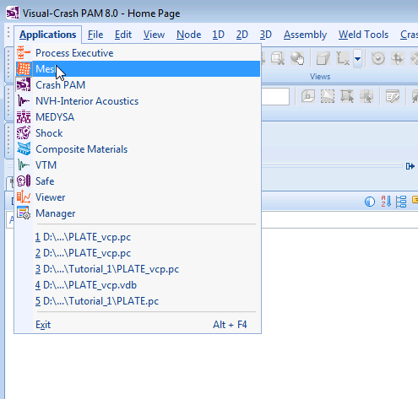
Select the option New file then specify the model unit system:  - Set Source Units to mm, kg, millisec, kelvin  - The target units will be the same  - Click OK  This specifies the unit systems (kN, mm, kg, msec). A units conversion to a different system could be made if needed; we use the same for both.  Alternatively, an old or partially completed model could be read in for further working using Open File and specifying the name of the file. | 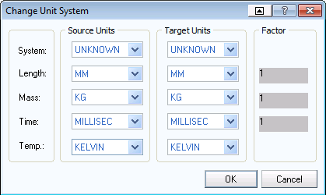
Some general comments before starting
Most mesh generation programs either allow the mesh to be generated by construction information (points, lines, surfaces, volumes, etc.) or use surface and volume data from CAD packages such as IDEAS and CATIA.
We shall generate the mesh here using some simple construction features in Visual-Mesh. The usual procedure is:
  - Specify key points in x,y,z coordinates.
  - Join these points with lines, arcs, circles, spline curves, etc.
  - Use these lines as a basis to construct lines for 1D elements, surface (patches) for 2D elements, or volumes for 3D elements.
  - Care has to be made during this process to make sure the generated mesh is appropriate to the loads, boundary conditions, part and material groupings that must be specified later in the process. Some advanced planning is needed!

Note: Visual-Mesh follows similar steps to make the mesh, but some useful tools are available to help simplify and speed the process.

Planning and specification of (nodal) points  The cantilever has four points that must first be defined. It is arbitarily chosen here that this model lies in the x-y plane with one corner at the origin (x=0, y=0) and the other points having the coordinates shown; (z=0 for all points). |  |  |  |  | (250, 50)  (0, 50)  x  y  (250, 0)  (0, 0)
Defining the (corner) points  The four corner nodes are defined using the Node > By XYZ, Locate… panel in which the coordinates for each node are entered and the Apply tab is clicked. The default ID numbers are used.  For the four nodes use a z=0 coordinate value. Note that the node ID numbers and their sequence are not important to the exercise. |  |  | 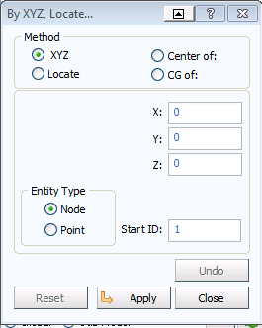  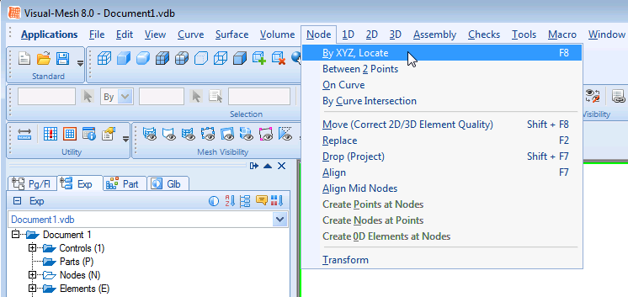
Positioning and viewing options:  Important options are available in the main (top) panel to position, center, zoom (in and out) and gererally vary viewing of the model.  - Tab options with the ‘left’ mouse key to position the model in the x,y,z or perspective (isometric) frame.  - Tab options with the ‘left’ mouse key to zoom in/out and generally position the model.  Spend 2-3 minutes to be familiar with these options; they are important. Use tab options (1) and (2) to center and position the model in isometric view. | 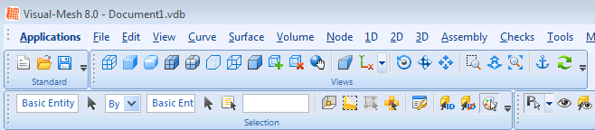  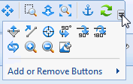  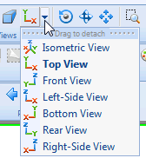  (1)  (2)
Generating the mesh surface  Activate the 2D > 3/4 Point Mesh tabs with the 4 point polygon option. Starting at any point click on the four corner nodes in sequence (clockwise or anti-clockwise). Note it may be necessary to use the previous positioning and zooming options to suitably position the nodes in the viewing frame. On clicking the last node the surface is generated as shown. |  | 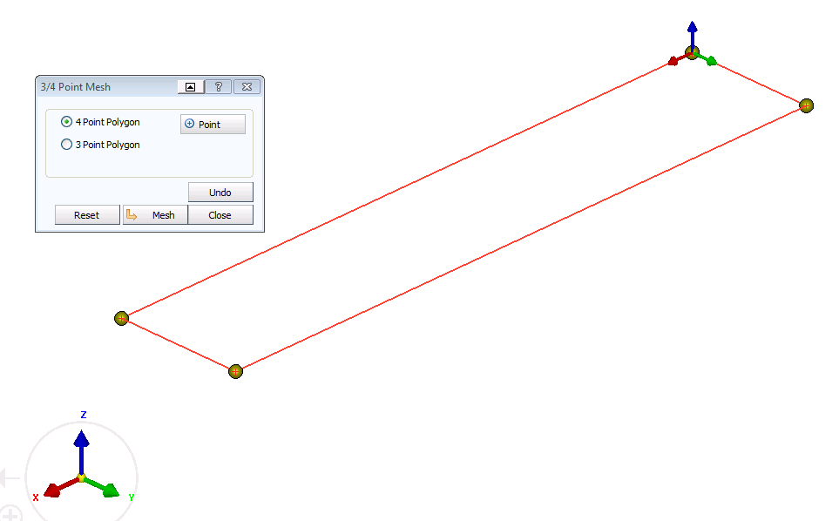
Generating the mesh  Click on the Create Mesh tab and a new panel opens to control the mesh to be generated. Element sizes, grading of meshed and connection options (stitching) to possible adjacent meshes can be defined.  Use a 10mm element size and click the tab Create Mesh. The mesh will appear; accept this with the OK tab and then Close to close the meshing panel. |  |  |  | 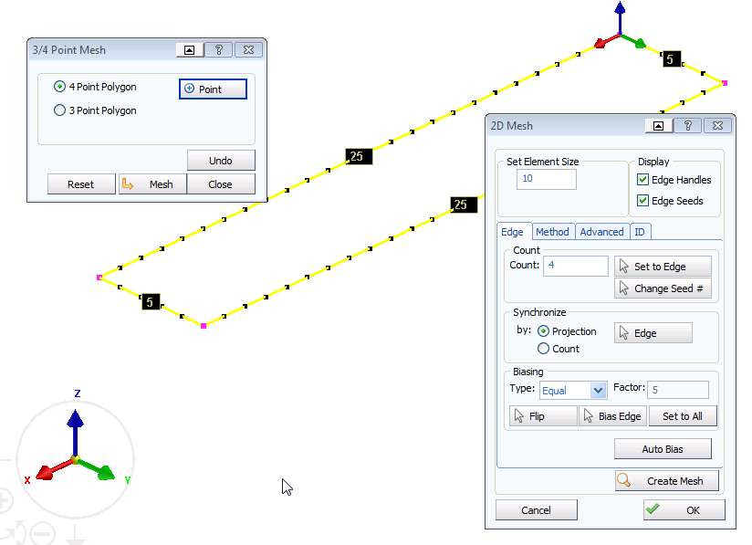
Ending the Visual-Mesh work
This now completes the meshing work with Visual Mesh. Save the data with File > Export to a suitable folder with a suitable name. Use the extension .pc which is the default name for a PAM-CRASH dataset.
E.g. a suitable name could be Cantilever_10mmMesh.pc
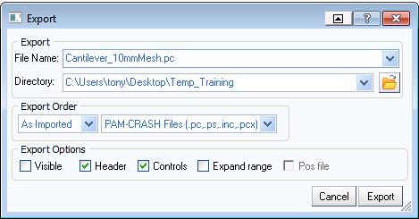
Remark: It is possible to use the File > Save option to save data in a binary (.vcb) format, which could be useful for large models and stores additional detailed information such as CAD data and meshing information. However, PAM-CRASH only accepts the ASCII (.pc) format and so this is used as the basis to store data throughout these tutorial exercises.
Closing VCP-Mesh
Use File > Exit to close the meshing session.
Remark: In priciple you could directly continue with the next operations to define entities, materials, etc., by switching back to Visual Crash PAM (Applications > Crash PAM) and continuing.
But it can be advisable stop, copy the dataset created to have a safe backup of the meshing work and then continuing; we shall do it this way.
Defining the model data (Visual Crash PAM)

Preparation of the model(s) for analysis  This involves:  - Starting Visual Crash PAM for definition of entities (Loads, boundary conditions, etc.,)  - Application of boundary conditions (fixed restraints at the built-in end).  - Application of loading at the opposite end.  - Definition of part (geometric) and material (mechanical) data.  - Definition of the PAM-CRASH control data (type of analysis – implicit or explicit) and other parameters. |  |  | 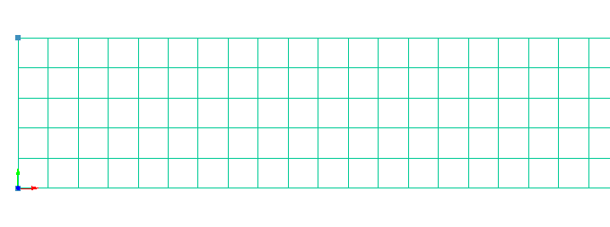
Copying files and starting Visual-Crash PAM
Copy the mesh file just created to a new name and work with the copied file. If things go wrong you could then go back to the mesh file and start again. Note there are no ‘UNDO’ capabilities in VCP; but you can always delete options and redefine then.
Copy Cantilever_10mmMesh.pc to Cantilever_10mmModel.pc.

Start the Visual Crash PAM and read in the new file (Cantilever_10mmModel.pc) using Open File.
Further viewing options  Useful options are available in the main control panels for viewing the structure (wireframe, polygon…).  Try these and then activate the ‘wireframe’ option. |  | 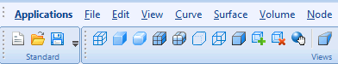  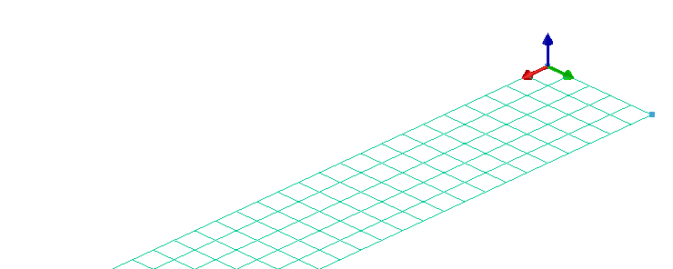
Positioning and centering of the model  Use the x-y and centering tabs to conveniently position the model as shown. This will make assignment of the bounday constraints, loadings and other data easier. | 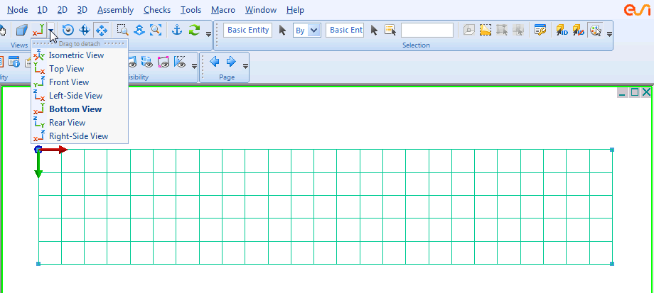

Boundary conditions (fixing the built in end to the wall and other constraints)  Click on the tabs Crash > Loads > Displacements BC to get the panel to assign nodes and boundary conditions. Use the left mouse key to drag a box over all the nodes at the left end (minus x direction) and click the green arrow to assign these. The selected nodes will now appear in the nodal list (see below; note your numbers could be different depending on initial meshing).  Now activate the required boundary conditions for these nodes:  - x,y,z are translational constraints  - U,V,W are rotational constraints.  Fix these nodes; in each case 1 means fixed, 0 means free. These are activated by clicking on each condition in the panel. Choose an appropriate title for the conditions; e.g. “fixed end”. Save the selection with Apply and Close.  Further boundary conditions: The problem will use 3D shell elements, but we would like to treat this as a pseudo 2D problem with only deformation allowed in the x-y plane. Therefore contrain the other ‘free’ nodes in the z direction by repeating the above operations for the new selected nodes. Save with Apply and Close. | 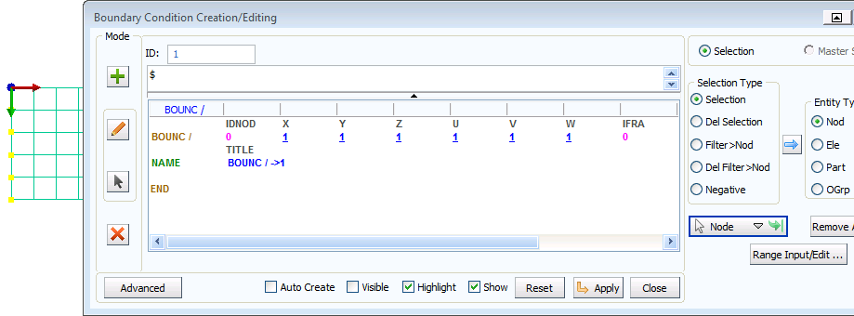  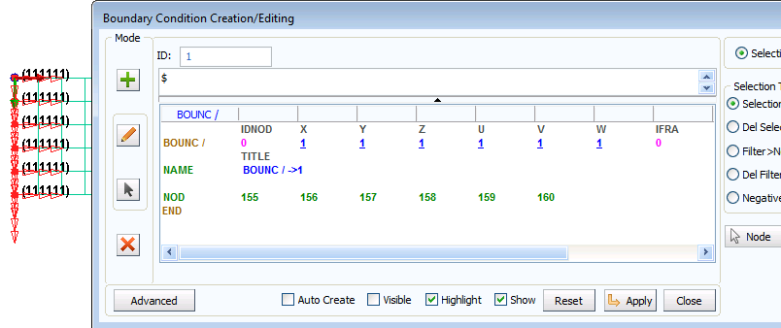  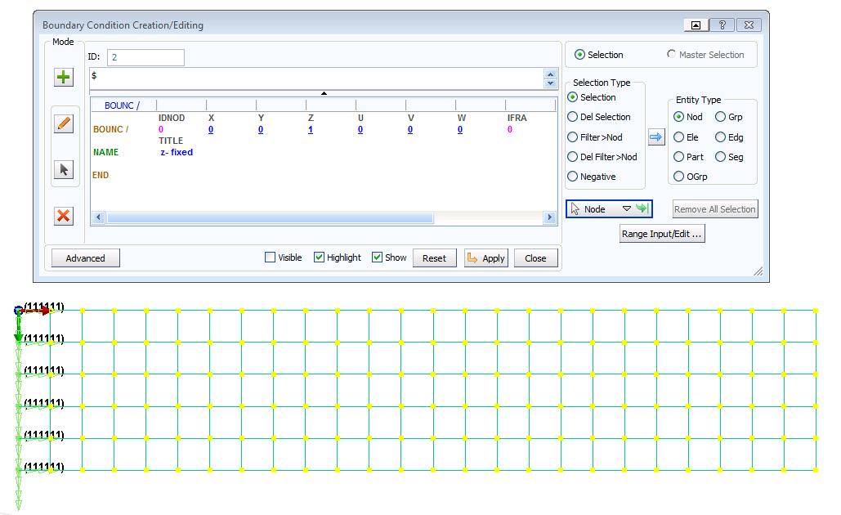
Visualisation (on/off) of entities  In the explorer panel (left tree directory) it is possible to edit entities and to switch on/off their visualisation.  Click on the solid blue circles to switch off visialisation of the new boundary conditions. | 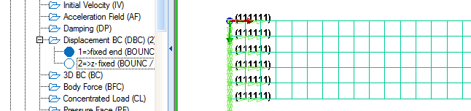

Loading conditions (at the opposite free end)  The aim now is to apply negative (y) loading at the free end.  Click on the tabs Crash > Loads > Concentrated Loads to get the panel to assign nodal loads. Use the left mouse key to drag a box over all the nodes at the right end (plus x direction of cantilever) and click the Green Arrow to assign these. The selected nodes will now appear in the nodal list. Give the nodal loads a suitable title; e.g “load 5kN per node” so it can be easily identified in the PAM-CRASH dataset file.  We now assign the loads to these nodes and a load direction. This is done using a load curve (which can have a constant value or a specific time history curve.  - Click on LCUR and then New to open a load curve panel. Click on File > New.  - In the new panel define the load curve function. The x-axis is time and y-axis is applied load. Assume the load starts at zero and increases to a constant 5kN at 5 msec, it is held at this value to the end of the simulation (=10 msec to be defined later).  - Click Assign Curve and Close  - Some last points:  - The load so far defined is positive and we would like this to be in the negative y-direction. A convenient way is to set the load scale factor SCAF =-1. Also, set the load direction IDR=2 (= y direction).  - Make sure the new load curve (LCUR=1) is assigned to this set of nodes.  - Use ILDTYP = 1 option so the load is applied to each node (i.e. 5kN at each of the 6 nodes giving 30kN total applied load).  - Note for a constant load the CLOAD option could be used.  Finish with Apply and Close. |  | 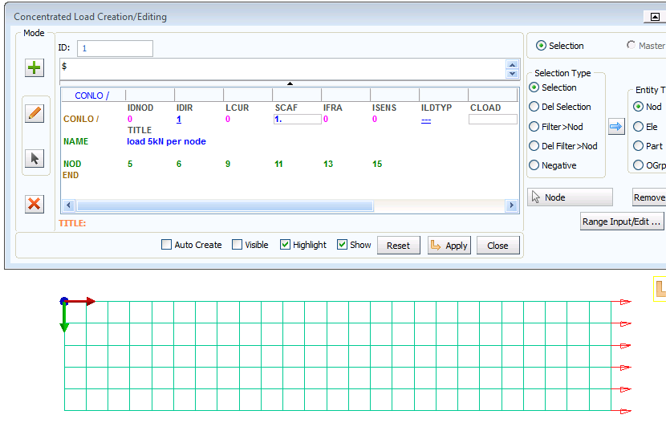  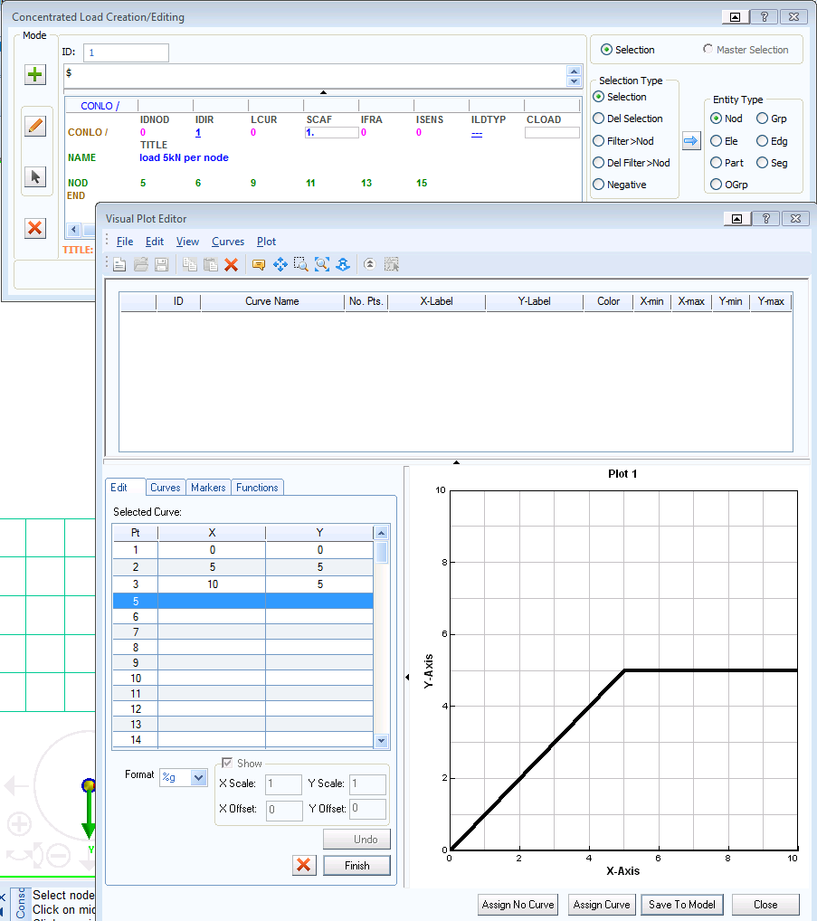  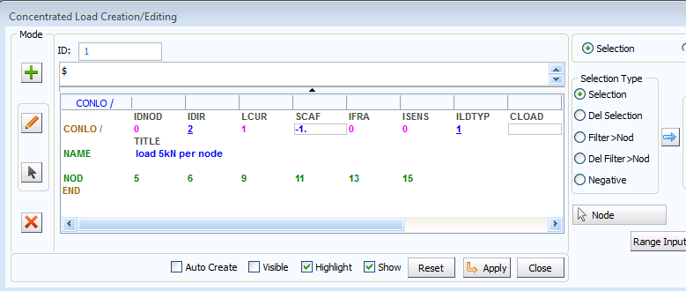
Assigning the Material and Part data  This is done using two entities which are linked together; namely:  - The Material data for material data such as modulus, density and plasticity information.  - The Part data for (geometric data such as thickness).  1. Material data  Select Crash > Material Editor and then select the type of Material Model; in this case use a 101 – ELASTIC_SHELL. Finally define the material data Steel (E=210 kN/mm², ν=0.3 and density 7.8*10⁻⁶ kg/mm³). Save with Apply and Close.  Remark: Make sure the units are consistent e.g. kN, mm, msec and kg; the analysis results will be in the same units.  2. Part data  This is most easily done via the Explorer panel:  - First click on Parts and the list of parts will open; select the required part. Press the left mouse key and activate the Edit option; the parts panel will open.  - Set the shell thickness to 2mm. Click just below H and set this to 2 (=2mm).  - Finally, the material is linked to this part. Click on IDMAT and the materials panel will open. Select the required material and click OK.  - Give the part a sensible title (e.g. cantilever).  Finish the assignment with Apply and Close. |  |  | 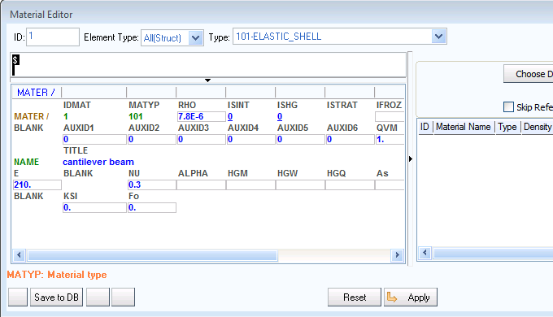  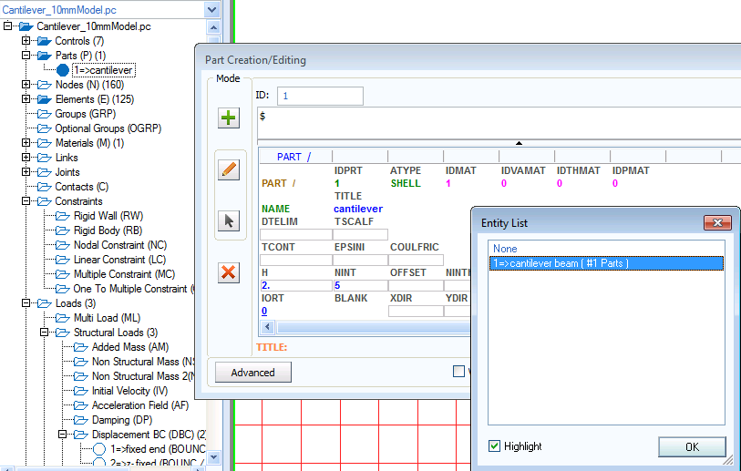
Output results  For later studies it will be useful to have details of time history information for the corner node (A) and an element (e.g. B 50mm from the wall).  For the node click Crash > Output > Nodal TH and select the corner node (A); click on it with the left mouse key. Then click the Green Arrow; give a suitable title and finish with Apply and Close.  For the element repeat the process using Crash > Output > Element TH and selecting the required element (B). | B  A  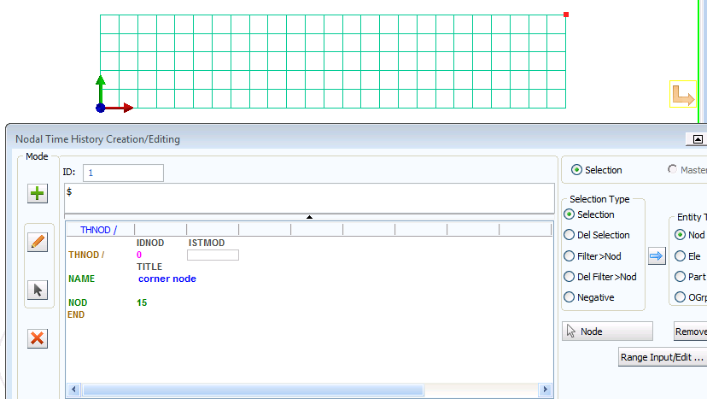
The PAM-CRASH control data must be set  This controls the analysis and allows specific data like the problem analysis time (in msecs in this case), specific output information and ouput intervals for the results.  In the Explorer panel under controls the following controls can be opened and edited (click on the control and open with the right mouse key to edit):  - INPUTVERSION: Set this (if necessary) to the latest PAM-CRASH version installed and used.  - ANALYSIS: Open if necessary and set this to EXPLICIT.  - TITLE: Open and give the project a suitable tiltle (e.g. Cantilever_10mmMesh); this will appear on all results plots using Visual Viewer and is important to help identify the analysis.  - RUNEND: Open and set this to (TIO2=10.0) for the solution time.  - OCTRL:  - Open and set the THPOUTPUT to POINT with 1000. This will save 1000 points of time history information for x-y graph plots in the .ERF results file.  - For DSYOUTPUT set option STATE with 50 to give fifty plots of the deformed structure in the .ERF results file.  - In these exercises results will be saved in the .ERF file format. In the OCTRL panel activate type 3 without compression (ICOMPRES=0).  - Save the information with Apply and Close. |  |  |  | 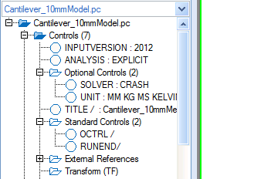  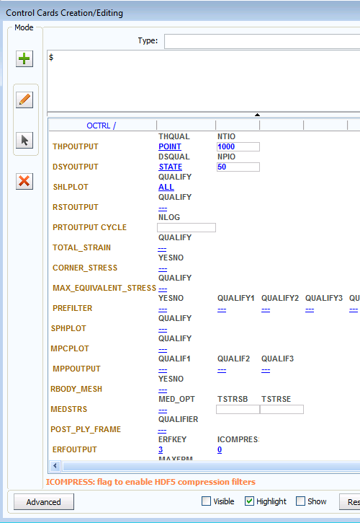
Finally, special output options  By default only limited node and element time history information is stored in the ERF results file; for example, nodal displacements and velocities, and element local stresses.  A wide range of additional information is available, but this must be specified. For example in the Explorer panel click on OCTRL then the right mouse key and Edit. Click the tab Advanced followed by SHLTHP > ALL > OK to output all available shell contour variables to the result files. Finish with Apply and Close. |  |  |  | 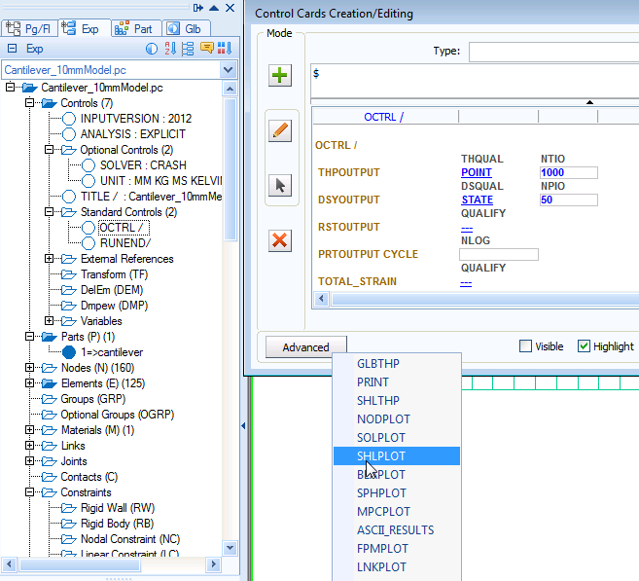
Saving the dataset (as a .pc file)  Click on File > Export and save the dataset in the required directory with a suitable name;  E.g. Overwrite the old Cantilever_10mmModel.pc file.  Be careful to make sure the export directory location is correct.  Remark 1: Files save in this way have the PAM-CRASH input file ASCII format and are readable. The File > Save option will save the model in a vcb internal binary format (it cannot be read by PAM-CRASH).  Remark 2: Some other dataset formats (e.g. DYNA3D and NASTRAN) are also possible to be saved: See the Data type options. |  |  |  |  | 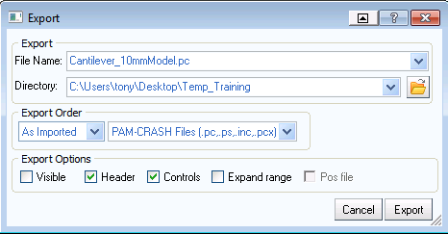
The PAM-CRASH (filename.pc) data file

The PAM-CRASH dataset (TOP)  Use a text editor to ‚inspect‘ the input file:  - The top of the file should similar to this.  - Work slowly through the dataset and try to identify the parameters you have set during the exercise.  - Do not worry if some nodes, etc., are slightly different. | 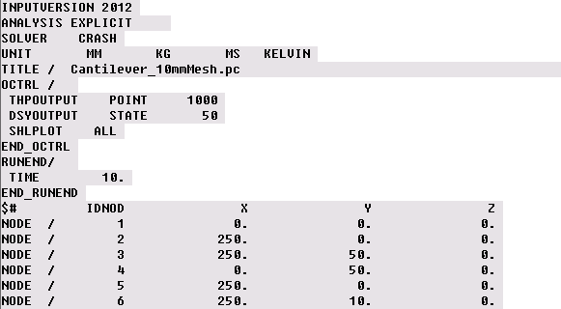  .  .  .  .  .  .
The PAM-CRASH dataset (BOTTOM)  - The end of the dataset should look similar to this:  - Note the naming scheme is fairly logical, for example:  - FUNCT – is a function curve (in this case the load curve)  - CONCL – is the concentrated loads data and the list of nodes to which it applies  - BOUNC – are the boundary conditions and applied nodes  - THNOD – are the time history nodes which will be output to the results files for x-y plotting | 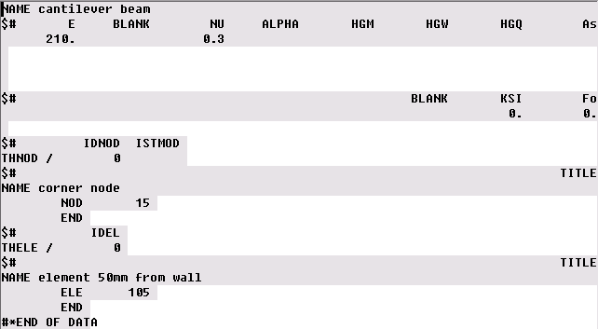

Part 2: Explicit analysis of the cantilever beam

Running a PAM-CRASH analysis  - Start the simulation run from the ESI Group Folder with the latest version of PAM-CRASH.  - Select the directory and your .pc file. It is also possible to select an SMP (shared memory) or DMP (distributed memory) version of the code for parallel processing and to select the number of processors you would like to run. The ‘Explicit Double Precision’ version is a recommended for training problems.  - If the dataset is good it will proceed through the dataset initialisation phase into the solution phase and terminate with ‘NORMAL TERMINATION’.  - If there are data errors the run will stop with an abnormal termination message. Inspect the output/results files for errors (search for ‘ERROR’ and investigate). Correct the dataset; preferably in VISUAL CRASH PAM (or in the editor) and rerun the analysis. | 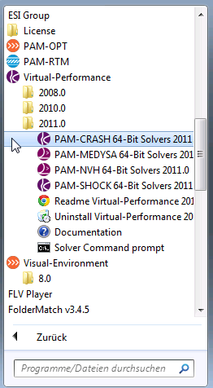  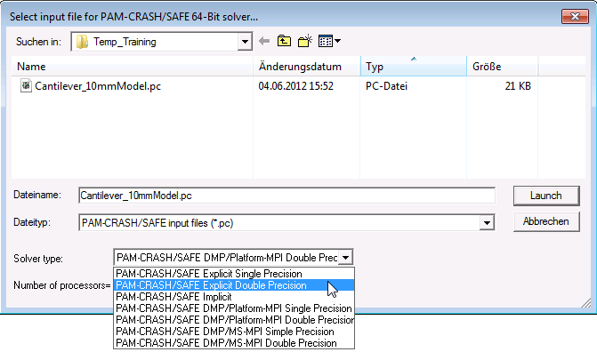  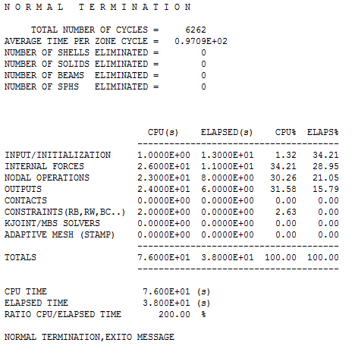
Evaluating the results (Visual Viewer)

First, we shall look at selected results of the deformed structure and some information that are available for contour plots of the complete structure; these are stored in the .ERF file (extension .erfh5) at selected time intevals (states). Following this we shall look at typical x-y plot information which is stored in the same file. The time output intevals for structure deformations and contours are different to x-y plot information and were specified in the Visual Crash PAM session.
  - Variable THPOUTPUT in the PAM-CRASH dataset controls frequency of time history plot information at selected nodes, elements, etc.
  - Variable DSYOUTPUT in the PAM-CRASH dataset controls frequency deformed states and contour information for the full structure.

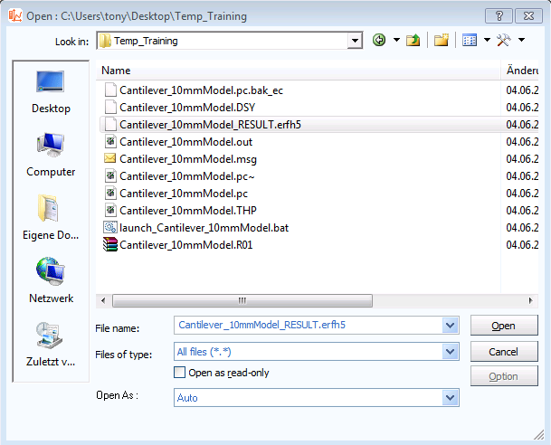
Mesh plot results
Start the Visual-Viewer program (from the same location as Visual Crash PAM); you will see that the layout of the program and most options to visualise and manipulate the part are the same as those used in Visual-Mesh and Visual-Crash PAM.
- Open the results file using Open File and select the .ERF file (i.e. Cantilever_10mmModel_RESULT.erfh5). Note the new file extension is _RESULT.erfh5.

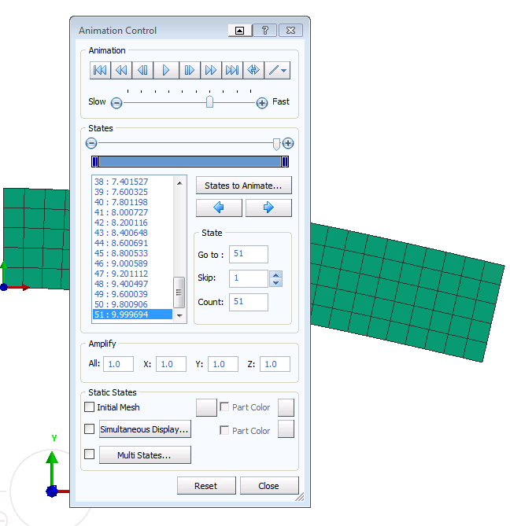
- Position the structure; for example center and view in the x-y plane.

- Click Results > Animation Control and you will be able to visualise the model and use the adjacent panel to examine deformations, either at a certain time, or as a continuous animation.

Use the Speed Control option to change the viewing speed in the animation option.

Additional tabs are available for overlaying the Initial Mesh or Simultaneous Display for viewing selected states simultaneously. Click Close to exit this option.
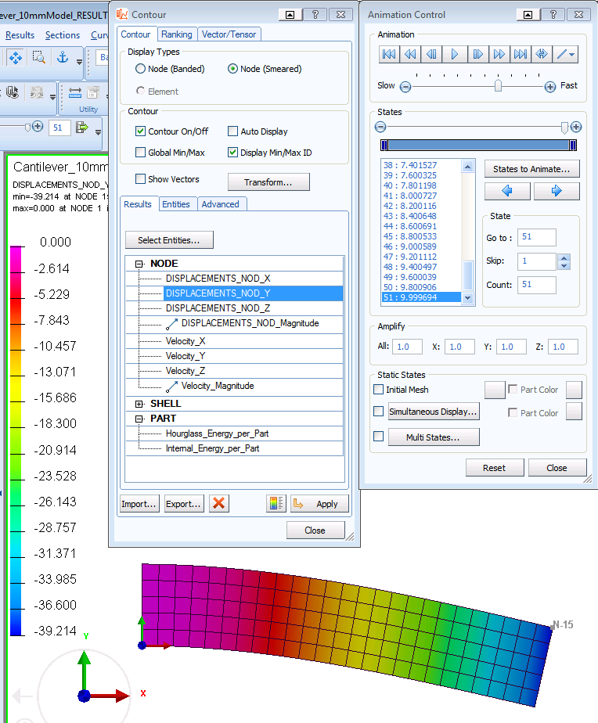
- Click Results > Contour and under Select Entities activate Displacements_Nod_Y and Apply. The contour distribution of nodal displacement (component Y) is shown with information on max/min values.

You will see various display options are available and the possibility to change contour limits if required.

This option, together with the previous animation control panel, allow different contours for both nodal and element variables to be visualised at certain time states, or as an animation.

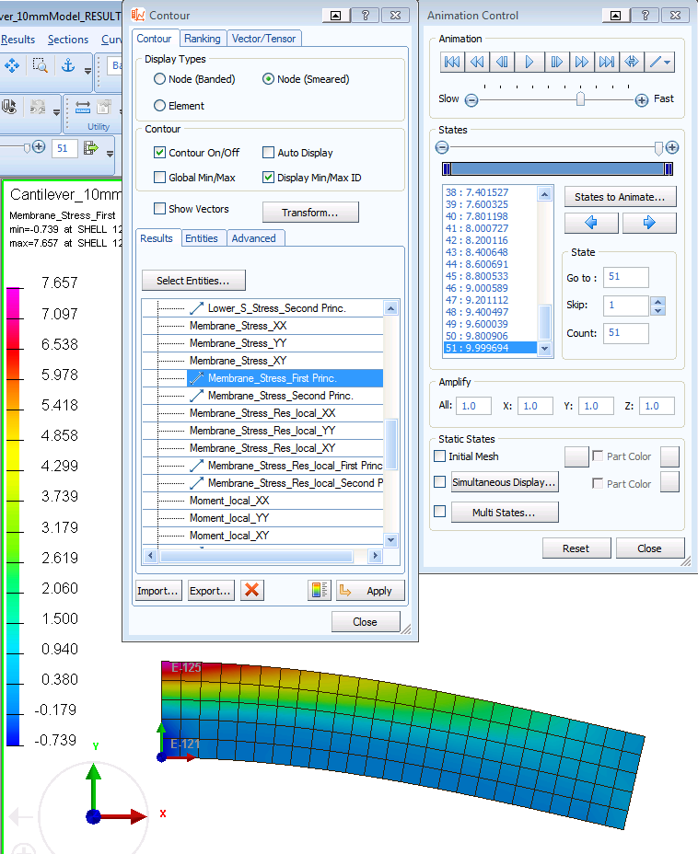
- In the Contour panel the entity type SHELL can be selected and, for example, the variable Membrane Stress First Princ. selected to plot the maximum principle stress distribution for the structure. The adjacent view is for the last state (≈10msec).

Time history results
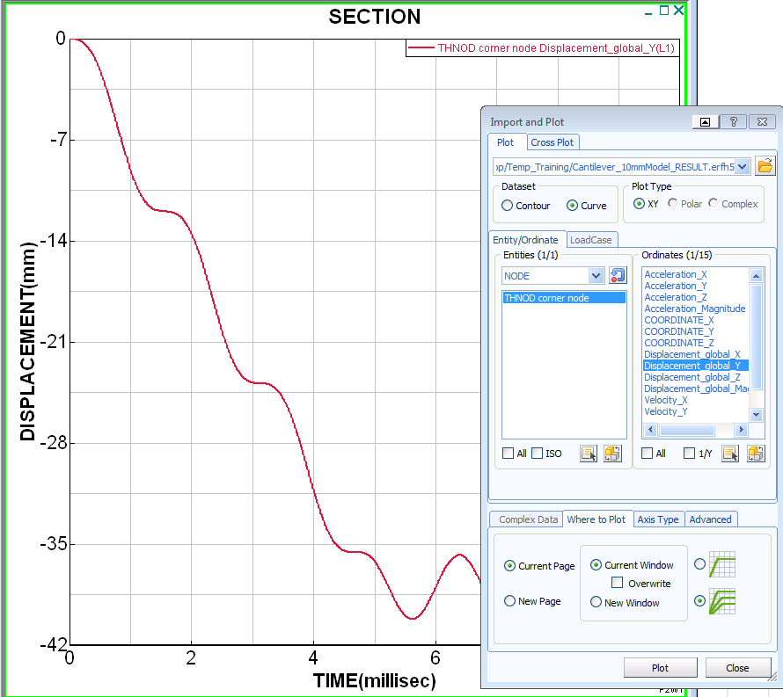
From the original Visual Crash PAM session two specific points of information where stored for x-y type plots; namely, the element located on the upper surface at 50 mm from the wall and the top corner node at the loaded end.

To collect this information click File > Import and Plot which will open the adjacent panel. Under Entities click NODE and a list of sored nodal time histories save will appear. In this case there is only the ‘corner node’. Click this and also the information to be plotted Displacement_global_Y and PLOT.

The red (oscillating) curve plotted is the displacement time history (component Y) for the upper corner node. The oscillations are typical and a consequence of the undamped dynamic explicit FE solution method.

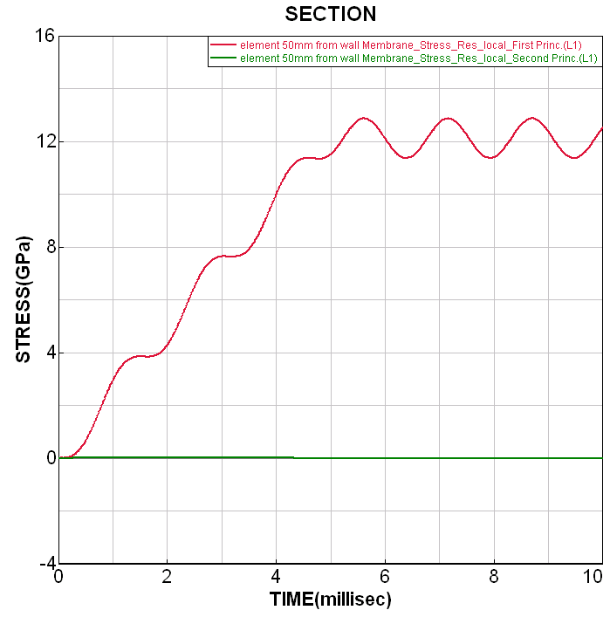

Using similar steps time history information for stress (and other) variables in selected element can be plotted.

In the Import and Plot panel activate the Entity Type SHELL:
Membrane_Stress_Resultant_Local_ First Princ. and PLOT,
then
Membrane_Stress_Resultant_Local_ Second Princ. and PLOT.

The two curves (one is nearly zero) are plotted for these principle stresses in the selected shell element.

Part 3: Exercises in explicit analysis

3.1 Quasi-static explicit analysis and nodal damping
The oscillations of the structure observed in the previous analysis are a consequence of the explicit integration method and the dynamic way loading is imposed over a short duration. For this simple beam structure these oscillations can be removed using nodal damping; a full description is given in the PAM-CRASH user and theory manuals.

Nodal damping should only be imposed once the structure is fully deformed under constant loading and in a state of dynamic equilibrium; in this case after 5msec. It should not be imposed during the loading phase as this will damp the loading deformations and in the case of elasto-plastic analysis may change the plastic distribution. The formula to imposed critical nodal damping is given in the PAM-CRASH manuals as,
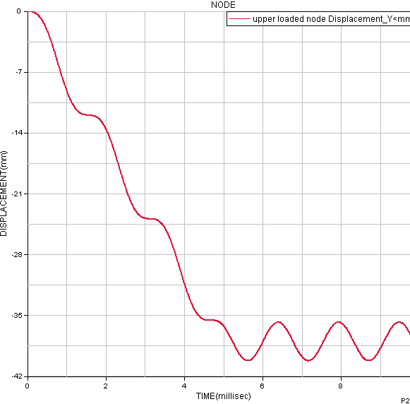
T

where T is the period of oscillation of the frequency to be critically damped; in this case T= 1.5 msec. Critical damping will damp the selected frequency over one cycle.

Damping is applied from 5 msec onward using two cases:
- Critical damping q_{crit} = 4 π / 1.5 = 8.38
- 20% of critical damping q = 0.2* 8.38 = 1.68

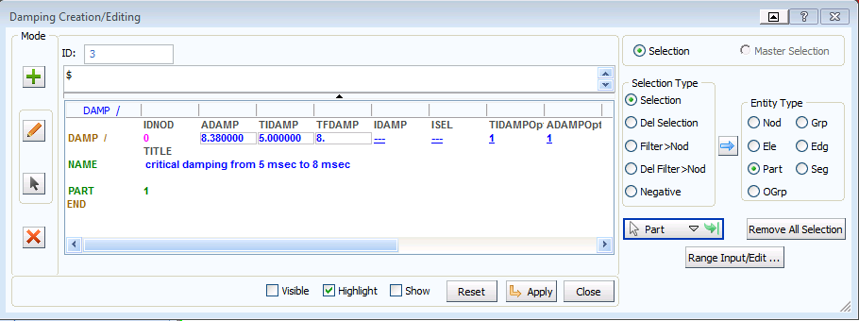
To apply nodal damping open the adjacent panel using CRASH > Loads > Damping. In the selection type click Part and then click on the structure in the main window and Update Selection to select the full structure for damping. The critical damping value is entered, together with a start and end time for damping of 5msec and 8msec respectively. Chose a suitable title and click Apply and Close to finish.
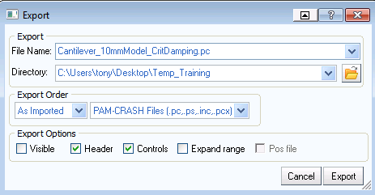

The modified dataset is saved using File > Export in a directory with a new file name, e.g.
Cantilever_10mmModel_CritDamping.pc

Repeat the same operations using 20% of critical damping (=1.68), with all other data remaining the same. Export the dataset as Cantilever_10mmModel_0.2CritDamping.pc
The two damping cases are run with PAM-CRASH to generate new .ERF results files:
Cantilever_10mmModel_CritDamping_RESULTS.erfh5
Cantilever_10mmModel_0.2CritDamping_RESULTS.erfh5

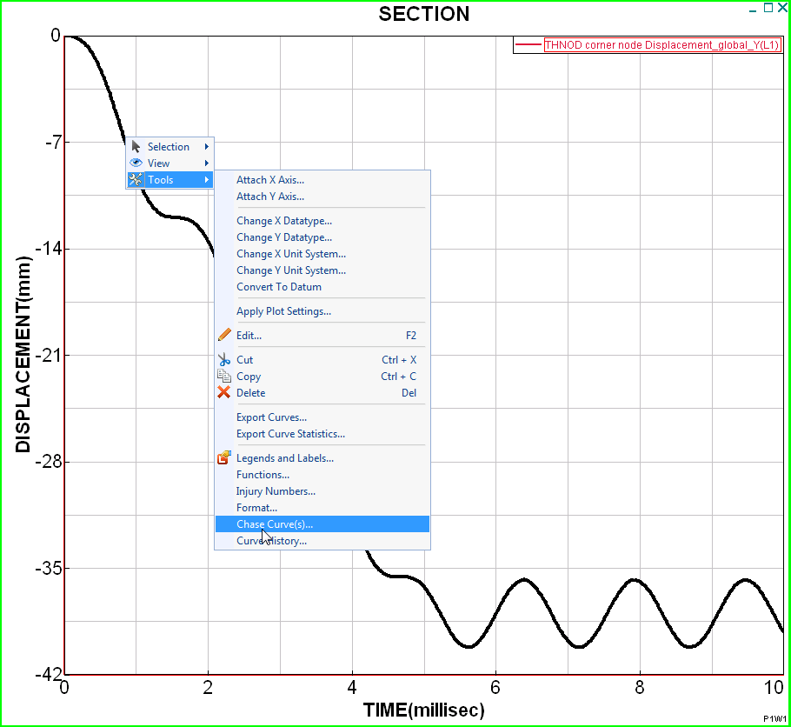
These results are now compared with the undamped solution for the corner node at the loaded end. Start Visual-Viewer and open the previous undamped results file (Cantilever_10mmModel_ RESULTS.erfh5); using the previous procedure plot the vertical displacement time history (Displacement_global_Y).

A convenient method to superimpose the damped results is to use the Chase Curve(s) option. Click on the current time history curve and it will change colour to black. With the right mouse key new options will open; click Tools and then Chase Curve(s). Using the windows folder options the damped results files (do one after the other) can be loaded and automatically plotted. Note there are options that appear to allow curve settings to be changed, for example the colour.
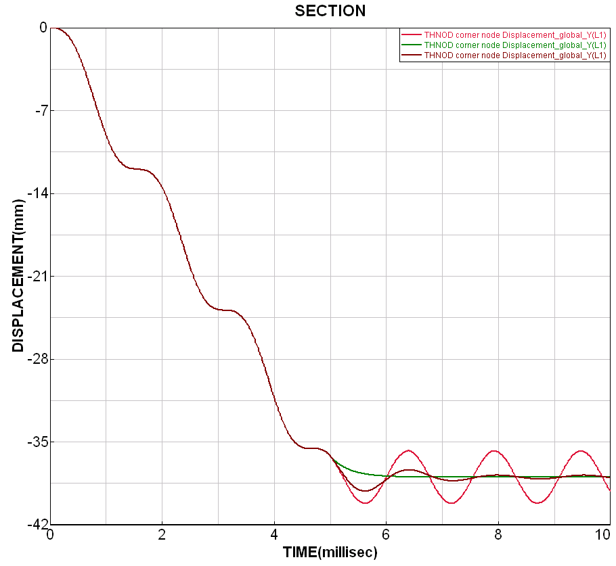

undamped
critical damped
20% damped

The displacement time history curves for the free end corner node shows that critical nodal damping has rapidly damped the structure within one oscillation, and that 20% has nearly managed this in the selected time window of 5 msec to 8 msec. In both case the final quasi-static deflection of the beam is approximately -38mm.

Remark: Generally, critical damping is not recommended as this can lead to stability problems; instead 10% to 20% of critical damping over 2-3 oscillation is preferable. In this study the damping was deliberately switched off after 8 msec to see if further oscillations occur, or if stead state equilibrium has been reached; it more-or-less has.
3.2 Mesh refinement and further analyses
In this section the 10mm FE mesh model is refined to give equivalent models having 5mm and 2.5mm elements sizes, and a model using triangular elements. These new models will be used to study several effects including hourglassing and solution convergence with refined meshes.

The following steps briefly outline the steps to prepare the new models.
- Start Visual Crash PAM and read in the 10mm meshed model (the one without nodal damping) that we have been using.
- This mesh is easily refined using the option 2D > Split and the splitting option shown below. All elements in the model must be selected. The new mesh has four times more elements with a new side length of 5mm. Finish with Close.
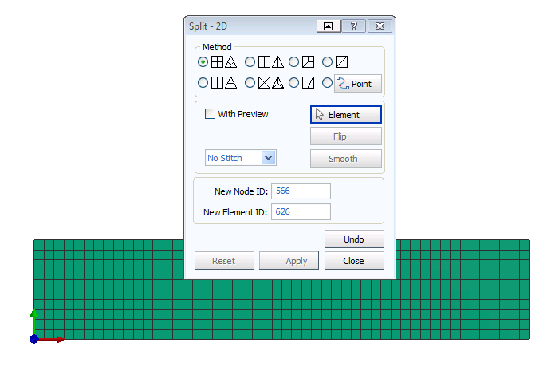

- Check the model: The material data and control data are good; but the boundary conditions and loading are not strictly correct (have a look) since new generated nodes have no boundary conditions or loads. However, the model is valid and we can it for now. Note that the total loading is still the same as the 10mm meshed model, although poorly distributed.
- Export the dataset with a new name (e.g. Cantilever_5mmModel.pc) and run it using PAM-CRASH.

Repeat the above procedure and refine the 5mm mesh model one level further (element side length = 2.5mm); again use a new file name when exporting (e.g. Cantilever_2.5mmModel.pc).
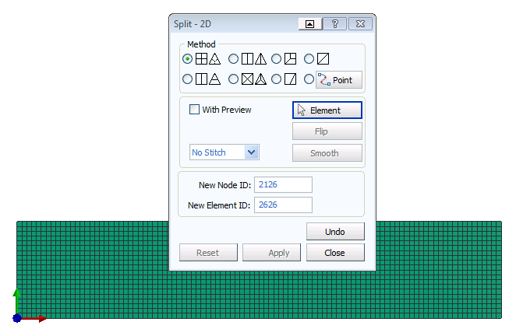
The two refined analysis models are run with PAM-CRASH and are now compared with the previously analysed 10mm meshed model. Only the undamped results are used in this comparison.
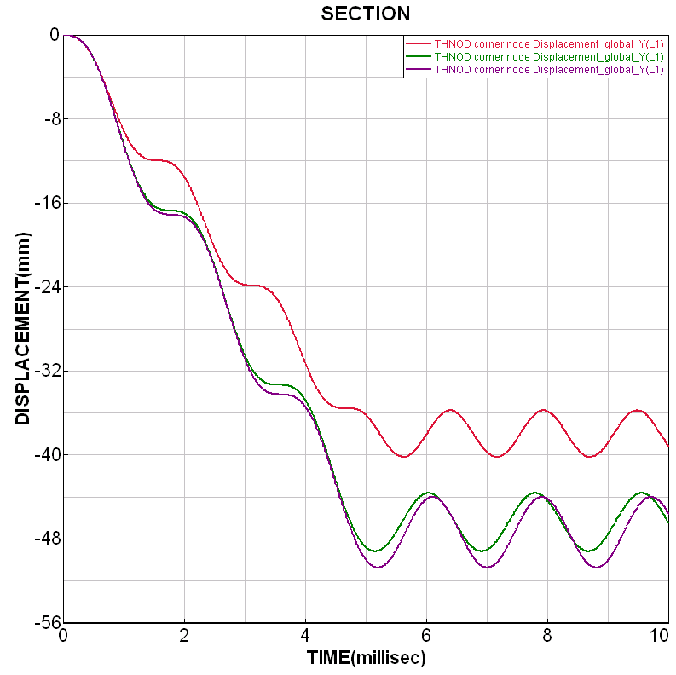
- Start Visual Viewer, open the .erfh5 results file for the undamped 10mm meshed model. Then plot the nodal displacement (Component Y) for the loaded end corner node.
- Use the Chase Curves(s) method describe in the previous section to superimpose the same displacement time history for the 5mm and 2.5mm meshed models; you should get the adjacent plot.
The 10mm element gives the lowest ‘average’ end displacement (≈ -38mm), whereas the 5 mm and 2.5 mm element mesh models both show greater average end displacements (≈ -47mm).

Titles and graph legends can be modified. Anywhere on the graph view click with the right mouse key to open Tools and then Legends and Labels. From the new panel new labels, font sizes and colours can be defined.
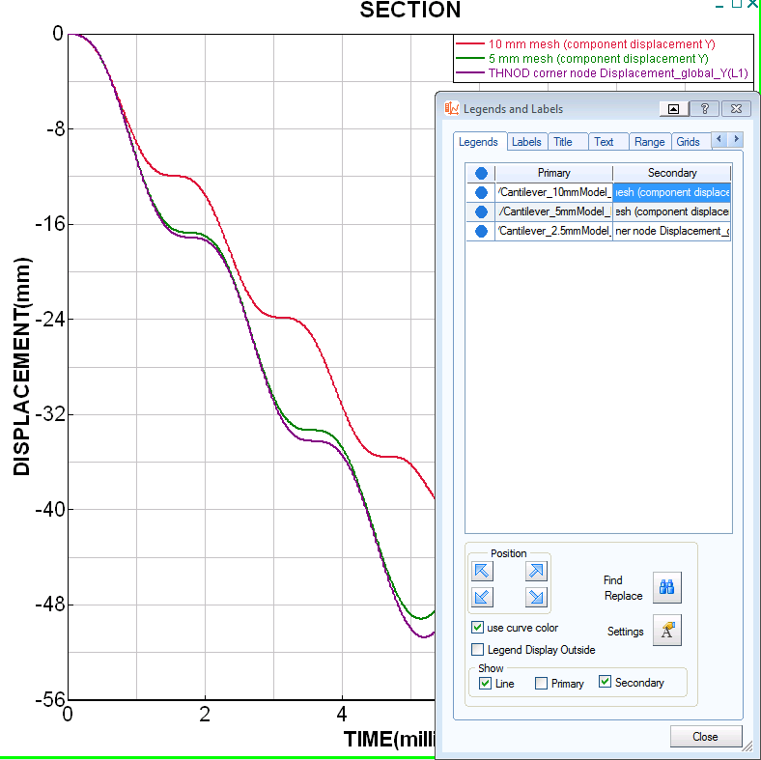
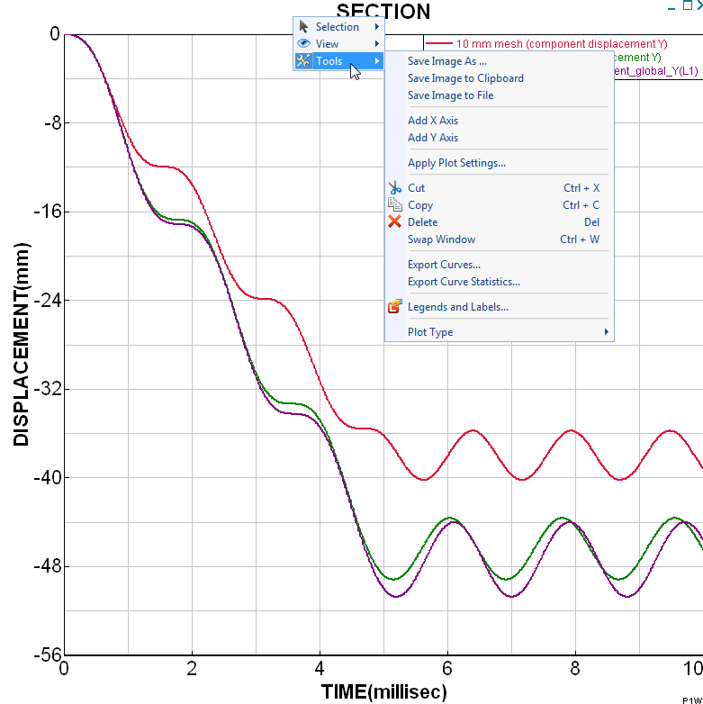

A close inspection of the deformed model at the restrained end, below, shows poor deformations and local hourglassing; this has led to (incorrect) greater end point deflection.
The boundary condition nodes come from the original 10mm meshed model, so only every second node in the 5mm mesh and every forth node in the 2.5mm meshed model is restrained. This is bad practice and all nodes should be restrained! However, it is an interesting result and the opportunity is taken in the next section to discuss hourglassing and methods to treat it.

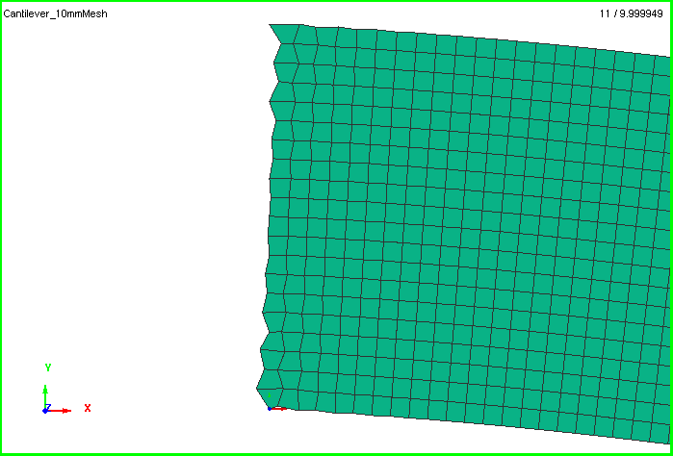
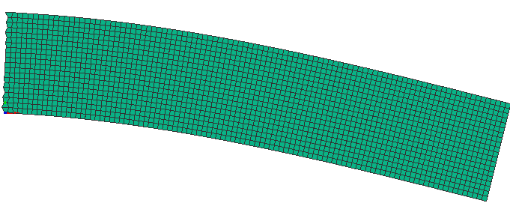

3.3 Element types and hourglass control
Hourglassing is a problem of under-integration techniques used in the numerical integration of element stiffness (or other quantities) and is especially common in ‘one point’ integration elements used in explicit FE codes. It is a phenomena that can be easily excited in regular meshed structures, or poor loading. A full description of hourglass theory and its control is given in the PAM-CRASH theory manual.

Essentially, hourglass modes are certain element deformation modes that erroneously predict zero deformation energy at the element integration point(s). For one point under integrated elements this point is at the centre of the element. Three methods could be used here to control, or eliminate hourglassing:
- Fully constrain all nodes at the boundary; this would be the best modelling approach.
- Use a different element type that does not have hourglass modes, for example 'fully’ or ‘reduced’ integrated elements, or triangular elements.
- Apply increased hourglass control parameters (this rarely is very effective).

For this study to control hourglassing the 5mm mesh model with the poor end restraints is used. Also, for easier comparison of solutions use the previous parameters for 20% critical damping for a quasi-static solution. Open the file Cantilever_5mmModel.pc, add damping and export as,
Cantilever_5mmModel_ 0.2CritDamping.pc

Method 1: Using the Hughes-Tezduyar (reduced integration) element
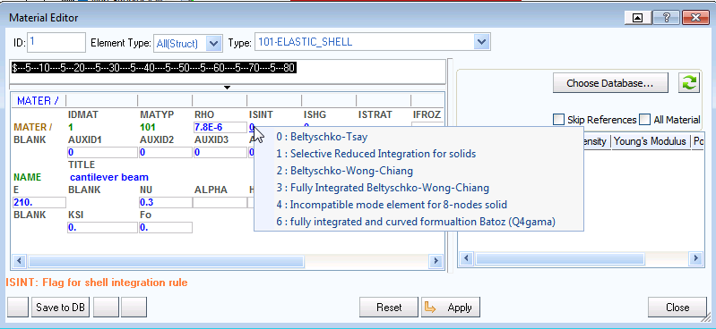
The Belytchko-Tsay shell element is the default PAM-CRASH shell element and was used in all previous studies. It is CPU efficient, but is under-integrated and can suffer hourglass problems. Instead the Hughes-Tezduyar element, which uses a reduced (2*2) integration scheme, is analysed. This is activated via the Material panel in Visual-Crash PAM (Shell element type 1 under the ISINT parameter). Make this change to Cantilever_5mmModel_ 0.2CritDamping.pc, export the file under a new suitable name and run with PAM-CRASH.

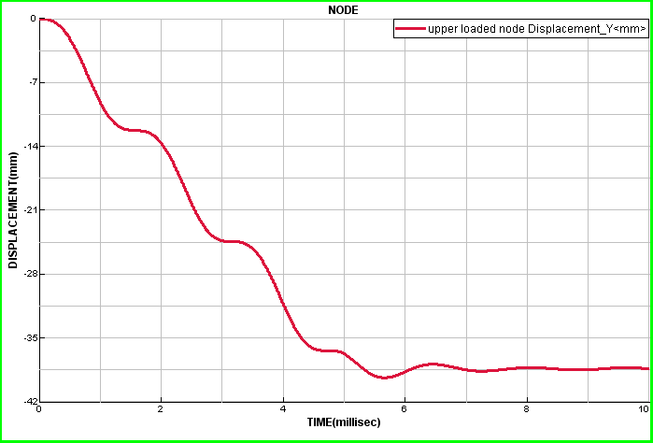
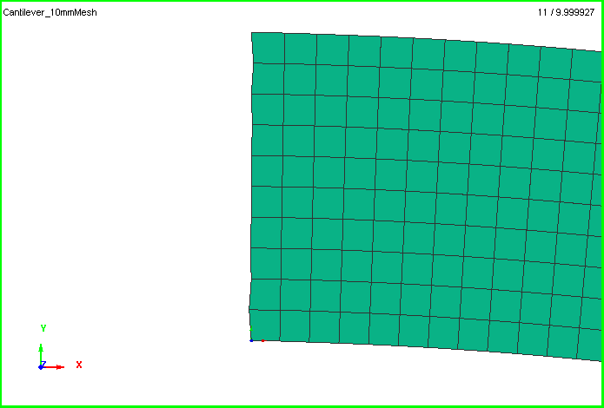
Analysis results show that hourglass modes are eliminated and deflections (=-38.5 mm) compares well with the previous 10mm mesh case using the Belytchko-Tsay element.

Method 2: Using triangle elements
The Belytschko-Tsay element is used (set parameter ISINT in the material cards) and the 5mm mesh model Cantilever_5mmModel_ 0.2CritDamping.pc is modified to have triangle elements. This is done using the Split option in Visual Crash PAM. Export the file under a new suitable name and run with PAM-CRASH.
The maximum deflection is about -36.5mm as shown below.
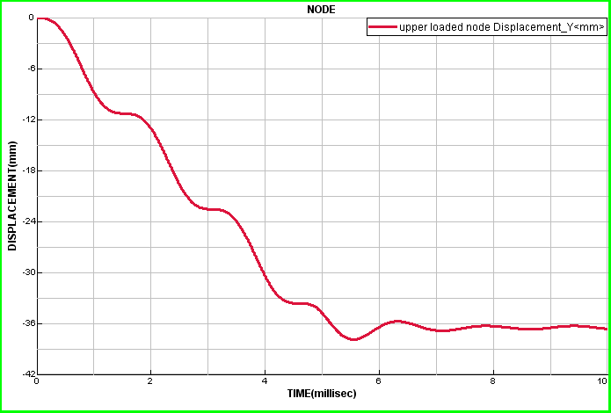
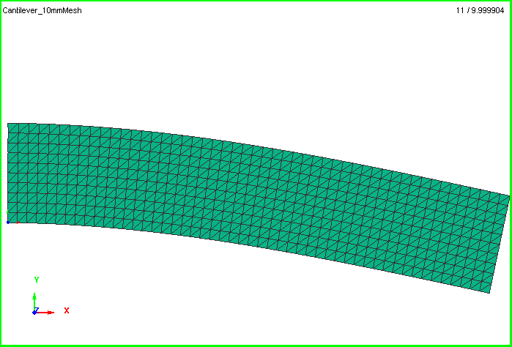

Note in this case the poor boundary conditions have been used but there are no signs of hourglassing. Triangle elements do not have hourglass modes. Also, it can be seen that the end deflection is slightly less (≈5%) than the quadrilateral element mesh result; this is due to this element formulation being slightly stiffer.

Remark: Hourglassing is actually very rare in analyses and should not occur if the standard PAM-CRASH hourglass controls are used in under-integrated elements.

3.4 Element convergence (explicit analysis with the Hughes-Tezduyar element)
It is expected that a ‘well behaved’ finite element should show a convergence trend. That is, analyses using increasingly refined meshes should tend toward a converged solution.

The following is a convergence exercise to try. Use the Hughes-Tezduyar shell element (to eliminate hourglassing) with 20% critical damping for a quasi-static solution. Compare maximum deflection at the corner node for the 2.5mm, 5mm and 10mm meshes.

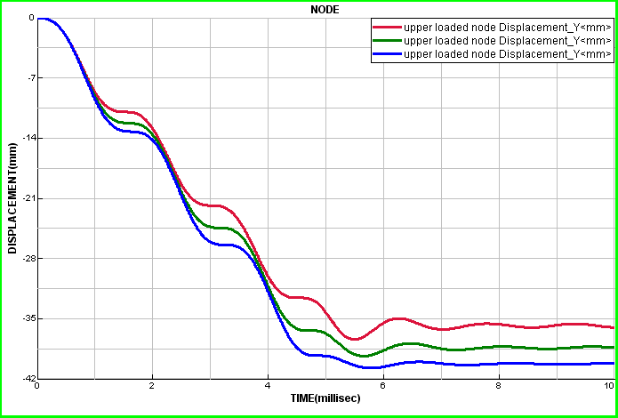
10mm mesh (125 elements)
5mm mesh (500 elements)
2.5mm mesh (2000 elements)
Results for deflection:

It can be concluded that this element has a good convergence trend and the final deflection is about 40mm (for this element type).

A similar study for triangle elements should also show convergence with refined meshes, but with slightly stiffer behaviour.

Part 4: Implicit analysis of the cantilever beam
The following briefly shows the simple steps needed to convert a PAM-CRASH Explicit dataset to an Implicit dataset. The changes are to the control cards only and are:
- To specify that an Implicit analysis will be undertaken.
- To specify that a Static analysis will be performed. In this case geometrically Linear analyses will be performed; in the next section this is changed to geometrically Non-Linear.
- To specify the element formulation to be used; in this case Element type 6.

There are two ways to do this, either:
Read the explicit dataset into Visual Crash PAM, make the necessary modifications outlined below, and export the modified dataset to a suitable new name, for example for each case:
Read in Cantilever_10mmModel.pc and export to Cantilever_10mmModel_Implicit.pc
Read in Cantilever_5mmModel.pc and export to Cantilever_5mmModel_Implicit.pc
Read in Cantilever_2.5mmModel.pc and export to Cantilever_2.5mmModel_Implicit.pc
Or
Make a copy of the datasets in advance and work with the copy. This is the safest way to do it as there is no risk to loose, or accidentially modify the original.

1. The implicit control card  In the explorer panel under Controls the type of analysis can be changed from EXPLICIT to IMPLICIT. Then click Apply and Close. | 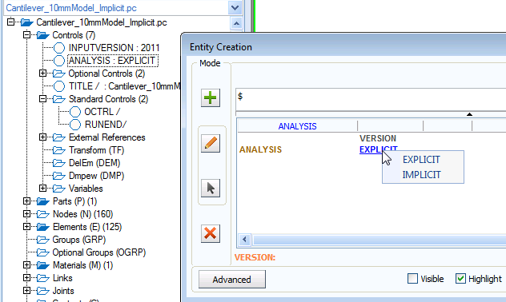
2. The type of implicit analysis  In the main window under Crash > Controls > Standard Controls look in the window Type for ICTRL. Click this and the adjacent panel opens. In the line ANALYSIS TYPE activate STATIC and LINEAR. Then click Apply and Close. | 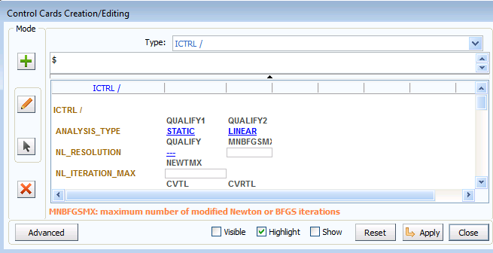
3. The element type  In the main window under Crash > Controls > Standard Controls look in the window Type for ECTRL. Click this and the adjacent panel opens. In the line SHELL FORMULATION activate type 6. Then click Apply and Close. | 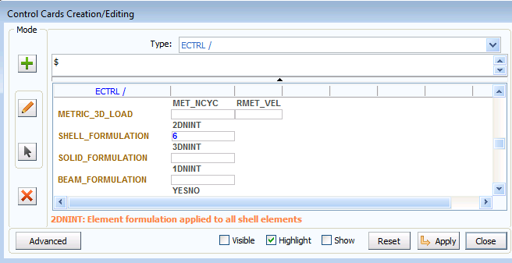
4.1 Static linear implicit results

Use PAM-CRASH Implicit to run the three implicit cantilever beam problems; namely, Cantilever_10mmModel_Implicit.pc
Cantilever_5mmModel_Implicit.pc
Cantilever_2.5mmModel_Implicit.pc

Results from the analysis are processed in exactly the same way as the previous explicit analyses using Visual Viewer; all results are stored in the respective .ERF files. The following plots show contours of deformations for the three models.

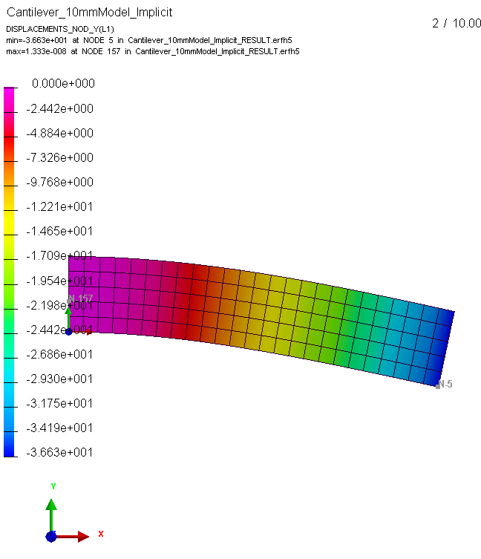 | 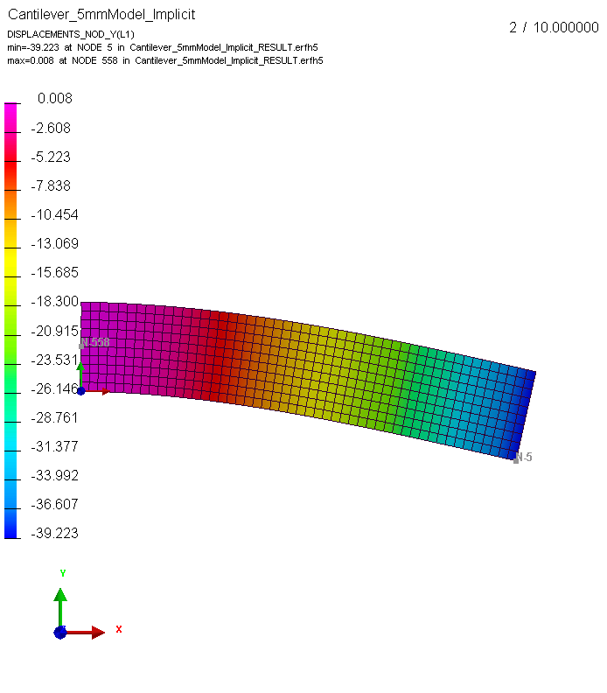 | 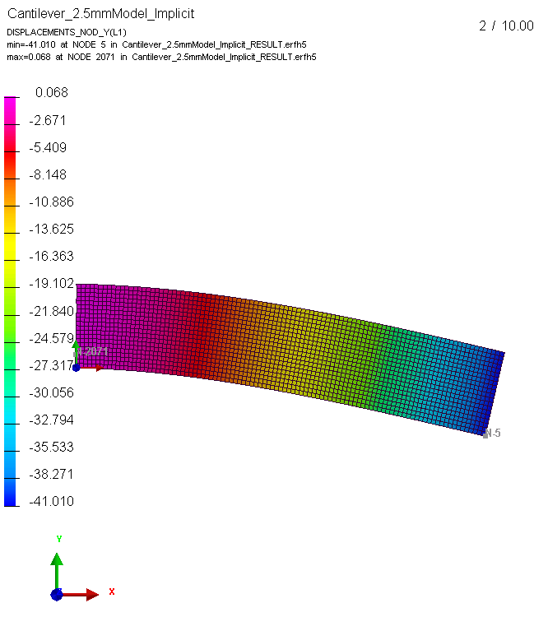

The three implicit analyses show similar results and trends to the explicit analyses with maximum y-deflections being:
for the 10mm mesh = 36.63 mm
for the 5mm mesh = 39.22 mm
for the 2.5mm mesh = 41.01 mm

Remark 1: Generally, the element shows a good convergence trend; that is, the more elements used the more accurate is the result and the results tend to a converged value.
Remark 2 : There is slightly greater displacement indicating this element type is less stiff than the previous element used in the explicit analyses.
Remark 3: For this case the linear implicit analysis is much faster to analyse than the explicit analysis. This is not always the case and implicit analysis can become CPU expensive if significant material and/or geometric nonlinearity occurs and is included in the analysis; see the next section.

4.2 Static geometric non-linear implicit analysis

Generally a static linear analysis will provide good results for most problems if the material is linear and displacements are small. In this case, however, displacements are large and a close inspection of deformations (look at the width of the beam along its length) suggests something might be wrong; indeed the beam gets wider!

Using Visual Viewer, open the 5mm mesh linear static analysis results. The deformed width of the beam at the loaded end can be measured using the ‘measure’ tab shown below. A new panel opens and then click on the two point to be measured. It is seen that the beam width increases from 50mm (undeformed) to 51.25mm which cannot be correct under this applied loading. A contour plot of nodal displacements (x-Component) also shows strange results that the beam does not shorten in the x-direction!

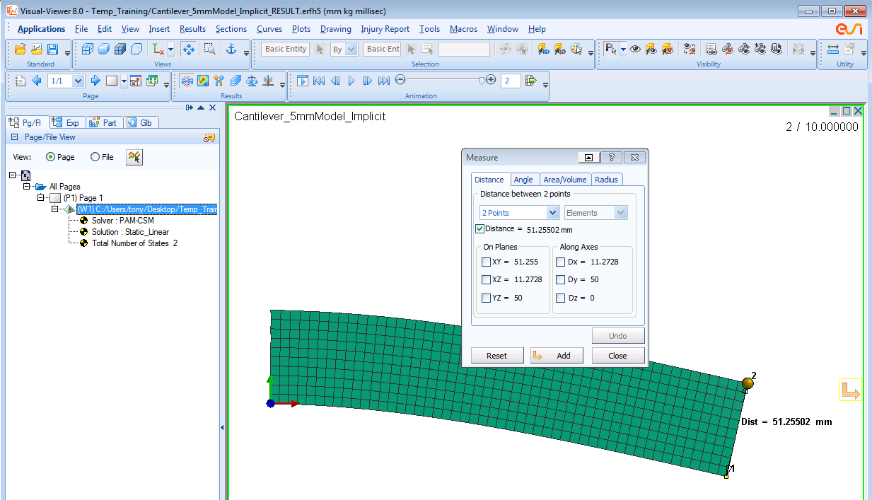

Remark: Linear static analysis is valid for most problems involving small displacements. In this case the derivation of the element stiffness matrix assumes a linear relationship between element displacements and strains and other simplifications are made regarding the interaction of element deformations and the material strains.
In effect these simplifications lead to a constant structure stiffness matrix that assumes a linear relationship between loads and displacements. This is not valid in this analysis as large deformations occur and a full geometric nonlinear analysis must be performed. In this case the structure stiffness matrix is a function of the displacements and a non linear iterative (e.g. Newton Raphson) solution is necessary.

A geometrically non-linear analysis can be activated in PAM-CRASH Implicit using the following changes; we shall do this arbitrarily for the 5mm mesh model.
- Copy the 5mm mesh case Cantilever_5mmModel_Implicit.pc to a new file; e.g. Cantilever_5mmModel_Implicit_GNL.pc.
- Change the “Type of Analysis”. In the Explorer window locate the existing ICTRL control card and change the Qualify2 from LINEAR to GEOMETRIC NON LINEAR, click Apply and Close to save the changes. Note it is still a static analysis problem.
- Finally, nonlinear analyses are performed as a series of load increments, with iterations being made at each load increment to an acceptable level of convergence. Information of the load steps must be given. This is controlled by the time value defined in RUNEND (=10) and the time increment which is set under Crash > Controls > Standard Controls and in the window Type for TCTRL. Set parameter DT2USR=0.2. These two values mean that 50 load increments will be made, which is a reasonable number.
- Note that the RUNEND parameter (=10) was the duration time used for all explicit analysis work. In the previous implicit analysis it had no meaning and was ignored.
- Export the model to the file Cantilever_5mmModel_Implicit_GNL.pc and run the analysis with PAM-CRASH Implicit.

Some results for the analysis are briefly presented
First, it is useful to look at a typical step in the output file. The time is specified and this increases from 0.0 to the end time 10.0 in intervals of 0.2. The number of Newton Raphson iterations for convergence is given together with output on solution progress for each load increment.

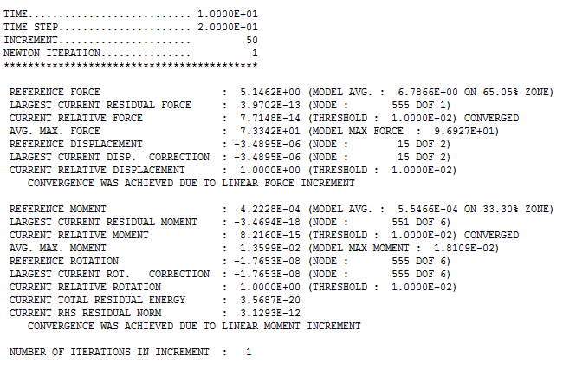

The following contour plot shows nodal displacements for the cantilever beam. The geometric non-linear analysis has now led to a correct prediction of structural deformations. In this case overall deflection of the beam is similar to the linear results; however, the width is now correctly predicted to be 49.986mm (~ 50mm)The stress distribution and x-component of displacements will also be correct.

