Tutorial 7

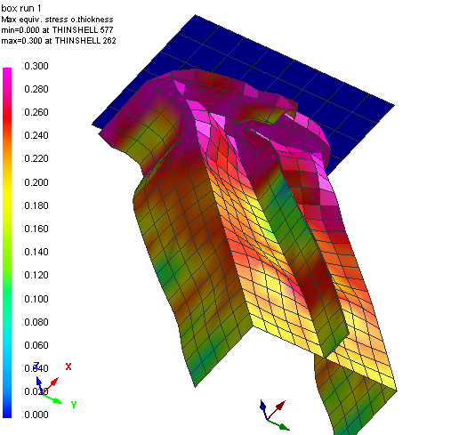
Axial Crushing of a Spotwelded Box Beam Structure

Problem description
Outline | Axial crushing simulation of a thin walled spotwelded hat section is undertaken including model setup and post-processing of results.  A convergence study with mesh refinements is made to show the effects on buckling modes and energy absorption.
Analysis type(s): | Explicit
Element type(s): | 3D Shell elements, Spotwelds
Materials law(s): | Elasto-plastic
Model options: | Boundary conditions, Spotwelds, Rigid walls, Contact
Key results: | Stress distributions and Impact forces
Prepared by: Date:  Version: | Anthony Pickett, ESI GmbH/Institute for Aircraft Design, Stuttgart December 2007  V4 (Updated May 2012 for Visual-Crash PAM V8.0)

Background information

Pre-processor, Solver and Post-processor used:
- Visual-Mesh: For generation of the refined model meshes (a completed coarse mesh model is provided).
- Visual-Crash PAM: To apply modifications to the models (boundary conditions, velocities, etc.,).
- Analysis (PAM-CRASH Explicit): To perform the explicit Finite Element analysis.
- Visual-Viewer: Evaluating the results for contour plots, deformations, etc.

Prior knowledge for the exercise
This exercise is not worked through in detail and it is assumed that the reader has gained a good working knowledge of the use of VCP from tutorials 1 through 6.
The completed model of the spotwelded box beam structure is provided and will be examined using Visual Crash PAM.
Problem data and description  Units: kN, mm, kg, ms  Description: Mild steel hat section (symmetric half model), spotwelded on the flanges is impacted against a rigid surface.  Loading: Impact mass (of the wall) is 100kg at a velocity of 7.8 m/sec.  Material: Steel (E=210 kN/mm² (GPa), ν=0.3 and density 7.85*10⁻⁶ kg/mm³). For plasticity a yield stress of 200 MPa and constant plastic modulus 1.0 GPa to a hardening plastic stress of 300 MPa is used. | 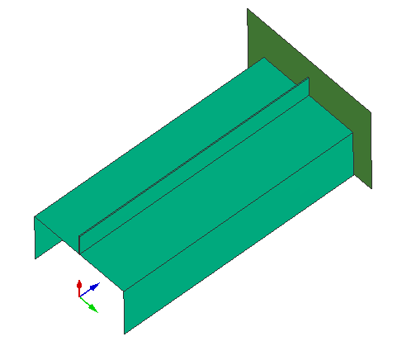  Rigid impact surface  Symmetric half of the box beam  235 mm  50.5  mm  101 mm
Supplied datasets
The completed coarse mesh model, including all entities, loadings, contacts and material/part properties is provided and has the name:
BoxBeam_CoarseModel.pc
During the exercise this model is modified and the mesh refined. It is recommended that copies of the coarse model are made, and these copies used later in the exercise; copy:
1. BoxBeam_CoarseModel.pc to BoxBeam_MediumModel.pc for the first level of refinement
2. BoxBeam_CoarseModel.pc to BoxBeam_FineModel.pc for the second level of refinement

Contents

Tutorial 7 1
Axial Crushing of a Spotwelded Box Beam Structure 1
Problem description 1
Background information 2
Part 1: Using Visual Crash PAM to examine the box beam 3
Part 2: Preparing the refined box beam models 8
Part 3: Running the models and investigating results 9
Part 4: Analyses with more spotwelds 11
Part 5: Increasing the box beam sheet thickness 12

Part 1
Model evaluation (coarse mesh) and explicit crushing analysis

Part 5
Increased sheet thinckness for improved crushing stability

Part 2
Refining the coarse model for medium and fine models

Part 3
Explicit crushing analysis: Comparison of mesh density models
Part 4
Improved spotweld distribution and crushing analysis

Part 1: Using Visual Crash PAM to examine the box beam

Starting Visual Crash PAM to examine the model  Start Visual Crash PAM and read in the file with Open File  BoxBeam_CoarseModel.pc | 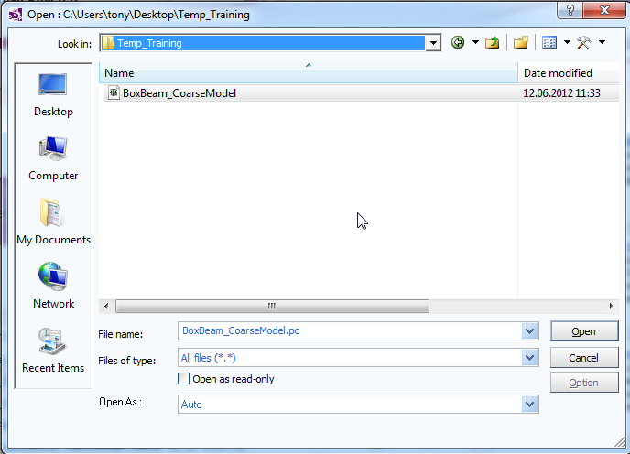
Viewing, positioning and centering of the model  With View > Window_Background Colour the background colour can be changed to white (if preferred).  Use options in the main (top) panel to position, center, zoom (in and out) and gererally vary viewing of the model.  - Tab options with the ‘left’ mouse key to position the model in the x,y,z or perspective (isometric) frame.  - Tab options with the ‘left’ mouse key to zoom in/out and generally position the model. |  | 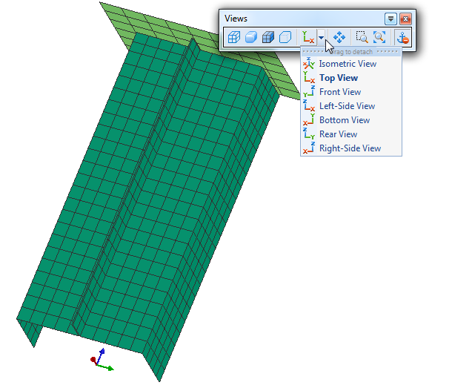
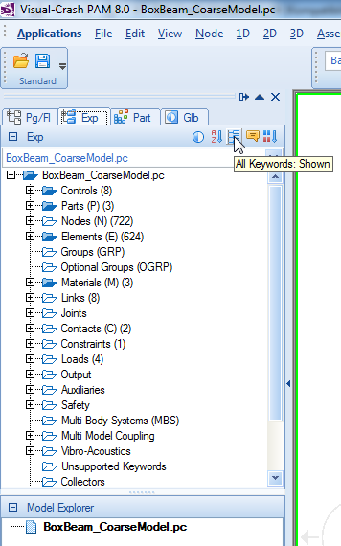
Examining the assigned entities
Most entities are most easily examined from the explorer panel (on the left side).
The first option indicated in the adjacent figure opens the explorer panel.
The second option indicated toggles between:
- All specified options in the model are shown.
- All possible options in PAM-CRASH are shows (this allows an alternative route to define options).
It is more convenient to view only specified options. Then simply click on the entity you want to examine and use the right mouse key to activate the option Edit. This will open a panel of the entity. The following examines the entities assigned to the coarse Box Beam model.
Parts and Materials
First take a look at the Parts and associated Materials.
In the explorer panel under Parts [+] and Materials [+] expand the lists. It will be seen that there are 3 parts;
- The steel box section
- The impact surface
- The spotwelds
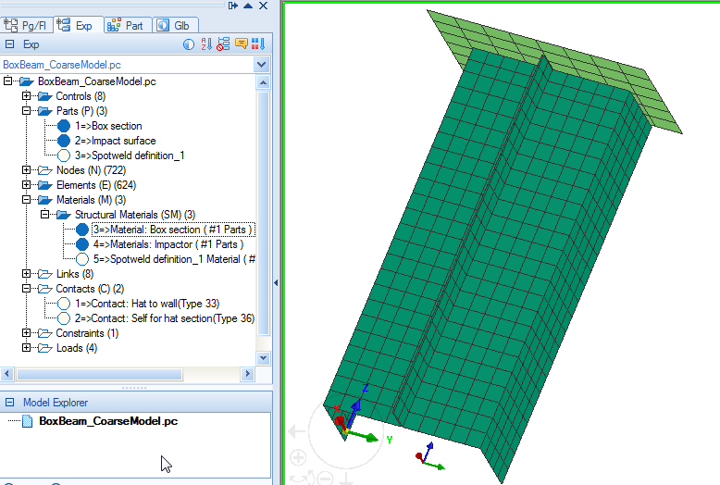
Each part has its own associated material. Examine the different parts and material properties.
Load(s) (Initial velocities and boundary conditions)
Next, the loads list is expanded to show that there is one initial velocity definition for the wall, and 3 displacement boundary conditions. In this study it has been chosen to fix the box section at its base and impact it with the wall (N.B. it is often the other way around!).
The wall has been defined as a rigid body and its COG node (=1000) has been assigned boundary conditions, a mass (see later) and an initial impact velocity.
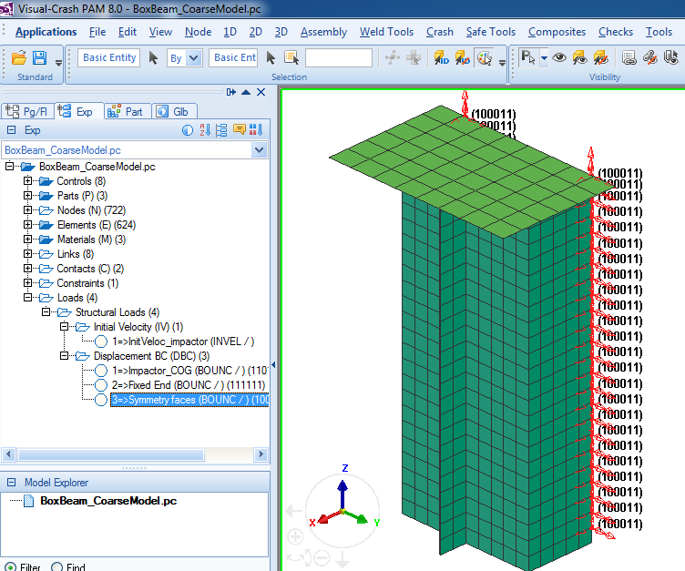
Examine the different boundary conditions. These allow z-direction motion of the wall, fully fixed free end of the box section and symmetry conditions (100011) for the box section symmetry plane.
Contact(s)
Two contacts are defined:
- A type 33 symmetric contact is used between the box section (slave) and wall (master); it is not important which is slave and which is master. This contact type allows contact force between the two parts to be monitored.
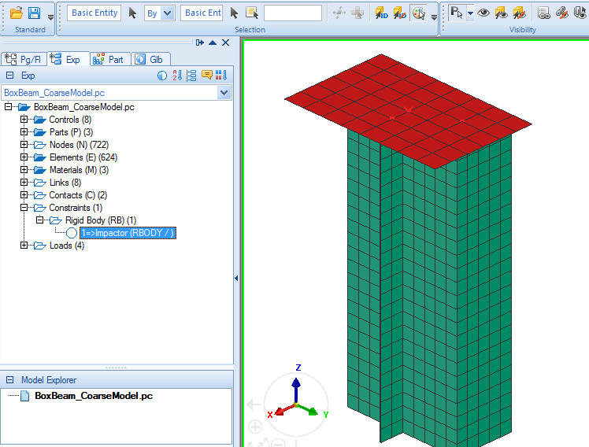
- The hat section undergoes complex folding and self-contact type 36 is most suitable. The wall could also have been included in this definition, but then the section-wall contact time history would not be available.
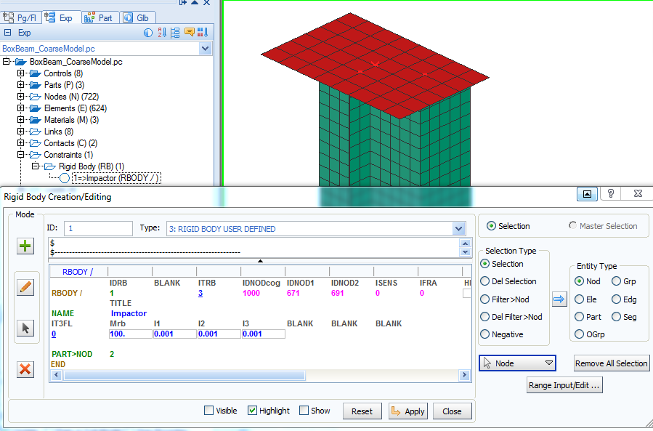
Rigid Body
For convenience the impact wall has been defined as a Type 3 rigid body.
This rigid body type 3 has been selected which allows mass and inertias to be assigned to the specified COG node. The assigned wall mass is 100kg; the inertias, in this case, have no real meaning due to the imposed boundary conditions.
Remark: The initial velocity and constraints to a rigid body must be applied to either all nodes, or to the COG node. In this case they are assigned to the COG node.
Spotwelds (PLINKS)
Useful tools are available in VCP to define spotwelds. Spotwelds can range from simple rigid bodies that tie nodes together to various mesh independent joints such as PLINKS (which are described in Tutorial 11).
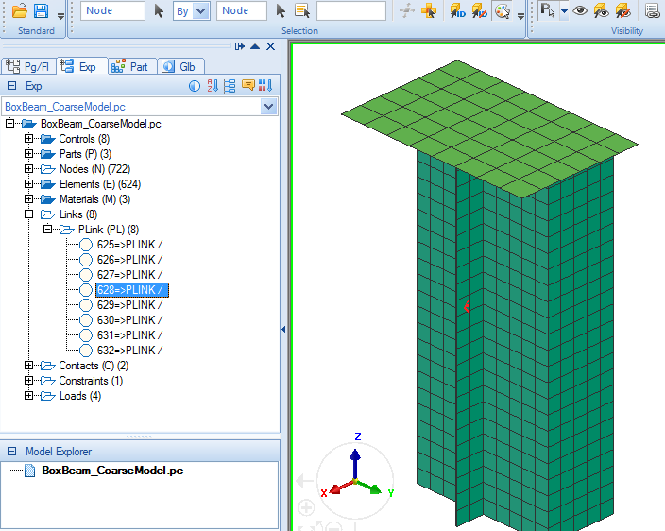
In Crash > Links > PLINK, simple individual PLINK’s can defined; it is necessary to specify an attachment node (or element) and then associate this to a Part (IPART) which contains information such as the search radius to locate the attachment point(s). This Part is also associated to a Material for mechanical, and possible failure data via an auxiliary Rupture Model.
Controls
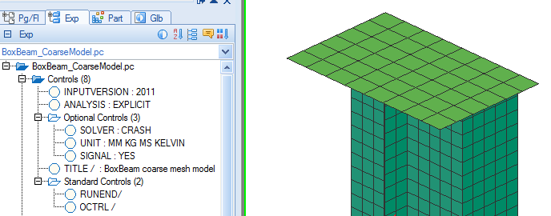
Control information on the analysis, termination time, file outputs and analysis title are available for viewing or changing in Controls > Pam Controls, or via the explorer panel and editing.
Saving the dataset (.pc file)
Click on File > Export and save the model as a PAM-CRASH ASCII dataset:
- Save the model in a suitable directory/name; e.g. BoxBeam_CoarseModel.pc
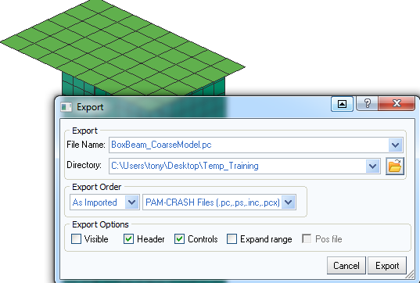
- OR, if no changes have been made, simply exit the Visual Crash PAM session without saving.

Part 2: Preparing the refined box beam models

Modifications are now made to the BoxBeam_CoarseModel.pc model using the copied datasets; that is:
1. Use BoxBeam_MediumModel.pc for the first level refined mesh model
2. Use BoxBeam_FineModel.pc for the second level refined mesh model
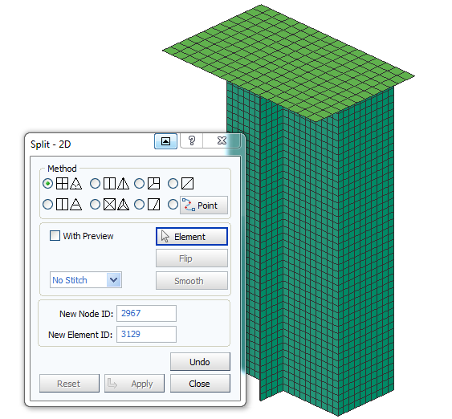
Procedure:
- Start Visual Mesh and open either, BoxBeam_MediumModel.pc or BoxBeam_FineModel.pc.
- Use the split option (2D > Split) to refine the mesh. For the medium meshed model perform this refinement once; for the fine meshed model do this twice.
- Change the analysis title in the Pam Controls; e.g. to “BoxBeam medium mesh model” for the medium mesh model and something appropriate for the fine mesh model.
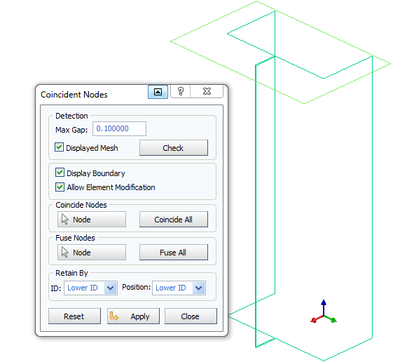
- Whenever using the mesh splitting options (and as a general check) it is advisable to validate the mesh is properly joined and without gaps (due to free or coincident nodes).
Use the Checks > Coincident Nodes option with a suitable gap size. The adjacent view shows that only proper edges are present and there are no internal gaps/edges. This option can fuse (merge) free nodes if required.

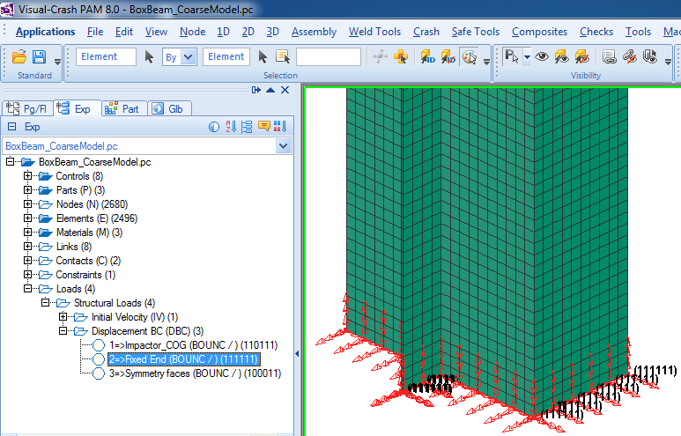
5. The splitting operation has introduced a new mesh with new nodes. It will be seen in the model that any existing nodal conditions, such as boundary conditions, only apply to the ‘previous’ coarse mesh nodes (not to the new ones).
The new nodes should also have appropriate conditions. This is easily done by updating the selection (e.g. by removing the old nodal list and making a new one by dragging a box over the required edge).

- Export the dataset with the same name;
either, BoxBeam_MediumModel.pc or BoxBeam_FineModel.pc.

Part 3: Running the models and investigating results

The Pam-Crash datasets are run. Then open the time history results file; e.g. file BoxBeam_CoarseMesh_RESULT.erfh5
in a new Visual Viewer session.
For this type of problem a free body (the wall), having a mass and initial velocity, strikes a deformable elasto-plastic structure it is possible to check the solution stability. In this case the Initial (Kinetic) energy of the impactor is converted to Internal (Plastic) energy in the structure. The Total energy of the system (=Kinetic+Internal) during the crash should be constant since no energy is added or removed from the system. Any numerical instabilities add energy to the system which will show as a spurious increase in Total energy.

Global energy plots and numerical stability
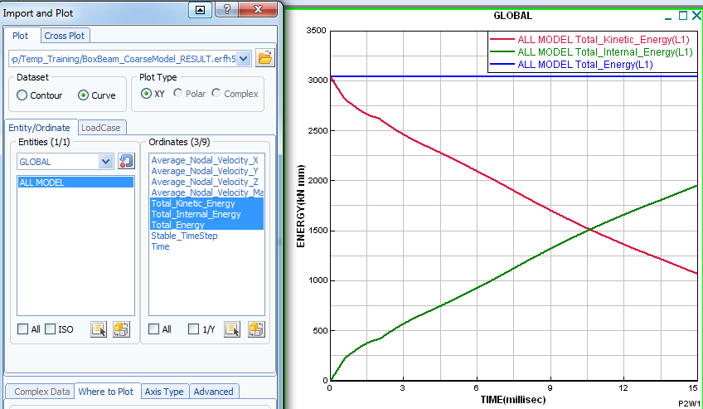
Plot the three global time histories for External, Internal and Total Energy. The tab for curve superposition is activated so that all three curves appear on one plot.
Notice the Total energy is constant indicating a stable solution.
Remark: A constant total energy does not necessarily mean the solution is good! Other factors, especially the deformation mechanisms must be checked carefully. Also, as demonstrated below, effects such as mesh density in critical problems should be considered.

Impact force time histories
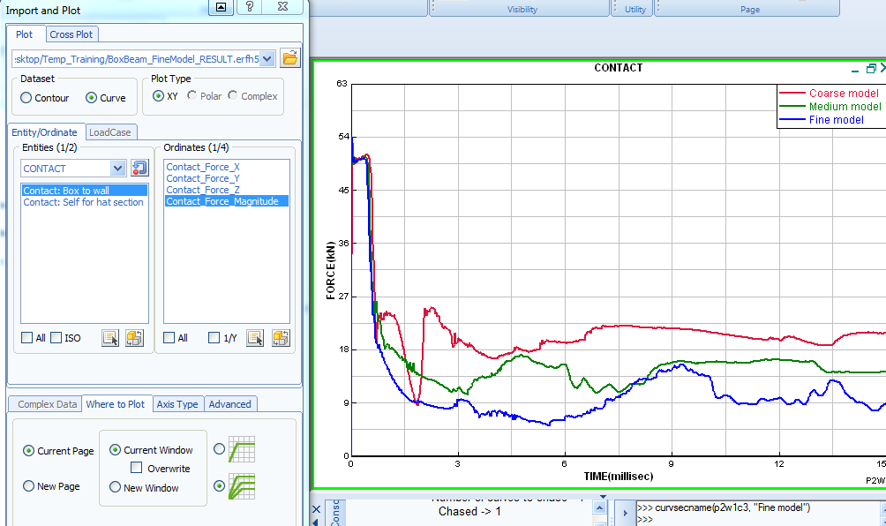
The adjacent plot shows contact force (Contact_Force_Magnitude) at the wall for the three simulations.

Plot the first time history (e.g. for the coarse model) using the options shown. Then use the Chase Curve(s) option introduced in Tutorial 4 to get the other curves.
Peak force due to plastification of the hat section at the wall

There is clearly a large difference in the impact force time histories. This is due to inability of the coarse mesh models to capture the true folding mechanisms and will lead to higher (unrealistic) energy absorption. Sufficiently fine meshes will converge to the true folding. An inspection of the deformation plots, shown below, is helpful to understand these trends.

Deformation plots
The plots below show the deformations at 7.5msec for the three analyses. The coarse mesh model has difficulty to capture the folding; however, the medium and fine mesh results are probably correct, but show the dangers that poor design of the spotwelds (insufficient number or inappropriate location). The spacing of the spotwelds is not in harmony with the natural folding (wavelength) of the section and has led to blocking and secondary folding at the rear of the section.
There are analytical models to determine folding wavelength of the section, or trial and error with FE simulation models can be used. An improved distribution of spotwelds would give stable progressive crushing from the front and improve overall energy absorption by preventing erratic crushing processes. Furthermore, poorly placed spotwelds are also likely to be highly loaded and could fail which would have serious effect on energy absorption.
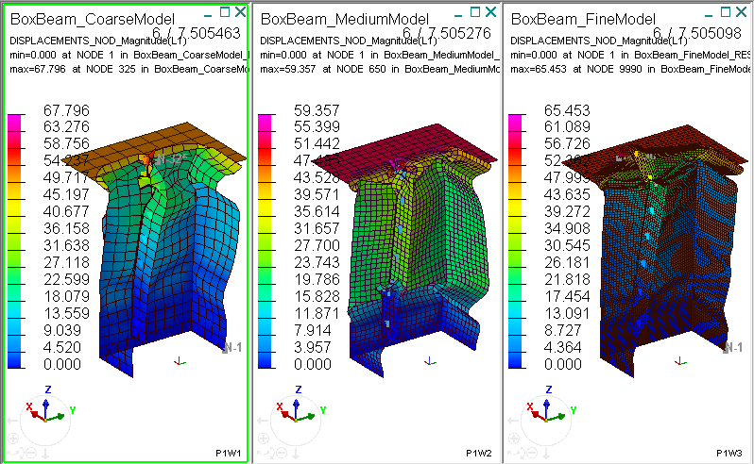

The following part introduces more spotwelds to try and improve stability of the crushing behaviour.

Part 4: Analyses with more spotwelds

Using more Spotweld elements
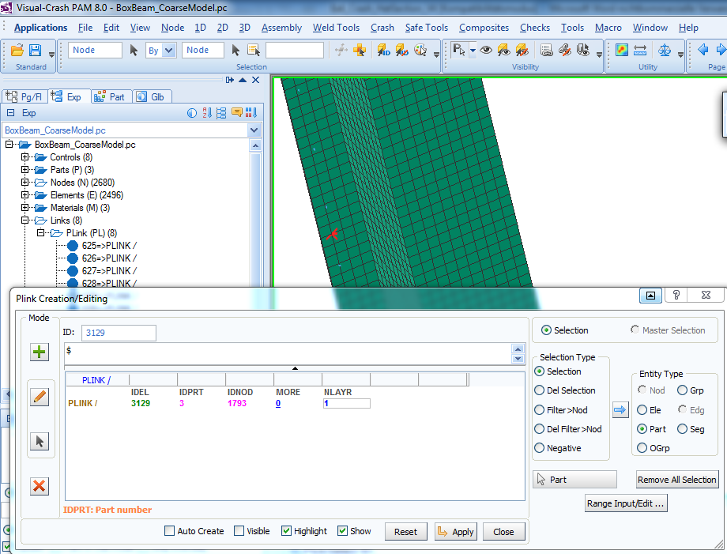
Using Visual Crash PAM it is straight-forward to add more spotweld (PLINK) elements to the medium and fine mesh models.

Use the Crash > Links > Plink option and identify new connection nodes; these are then associated to the existing Part (=3) for Plink elements. Add all the new Plink elements between the existing ones, change the analysis title and export the dataset. Try this for both the medium and fine meshed models creating the new datasets:
BoxBeam_MediumMesh_MoreSpotWelds.pc
BoxBeam_FineMesh_MoreSpotWelds.pc

The contact force time histories for the new models with spotweld spacing of 15 mm are compared below with the previous fine mesh model having spotweld spacing of 30mm. The impact force time histories and deformation plots do show some improvement; however, the collapse is still somewhat unstable. The following (last) exercise increases the overall thickness box beam sheet thickness to 2mm to try and improve section stability.

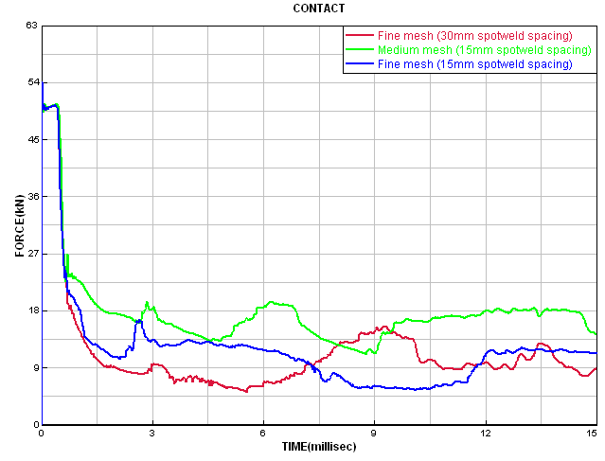
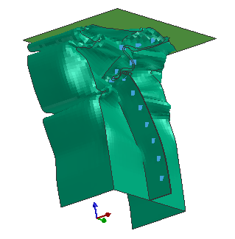
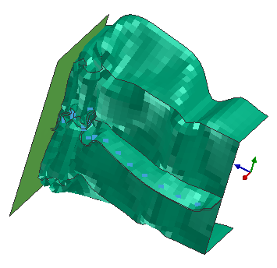
New fine mesh model - spotweld spacing 15 mm
Old fine mesh model - spotweld spacing 30 mm
New medium mesh model - spotweld spacing 15 mm

Part 5: Increasing the box beam sheet thickness

Increasing the sheet thickness
Use Visual Crash PAM (or directly edit the dataset) to increase the sheet thickness from 1mm to 2mm; this is defined in the Parts cards. The thicker sheet will also absorb more energy so it is interesting to increase the impactor mass (Rigid body impactor from 100kg to 200 kg) and also to increase the run time (control parameter RUNEND) from 15msec to 20 msec. Save (Export) the new dataset with an appropriate name,
e.g. BoxBeam_FineMesh_MoreSpotWeld_Thick2.pc

Run the new model and open the results file (.erfh5) with Visual Viewer. The deformation now shows a stable collapse and the wall impact force time history shows a typical cyclic form as the section collapses, lobes on the folds meet and the force increases until the next cyclic collapse starts.
The section plot shown below is produced via option xxxx

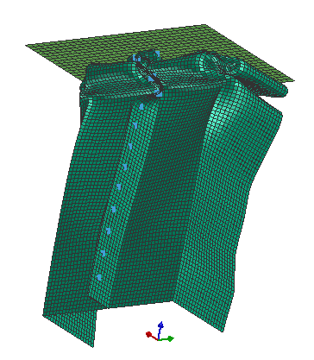 | 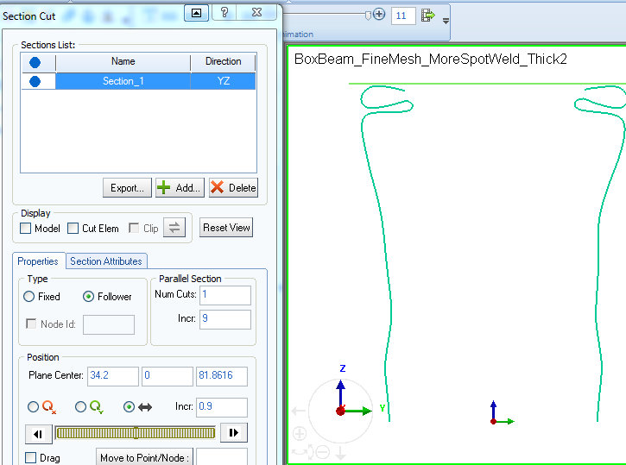

PLOT for time history

